**2022**

Subhasish Pattanaik

Edureka Association with Purdue University

12/30/2022

PROJECT 1 BUILDING A CICD FOR ABCtechnologies RETAIL COMPANY

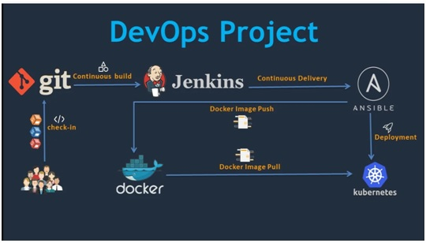

**Introduction**

DevOps stands for Development and Operations. It’s a software engineering approach that focuses on bringing the development and operations teams together to automate the project at every level. This method makes it simple to automate project service management to support operational goals and gain a better grasp of the technological stack in use in the production environment.

This approach is based on agile methodology and emphasizes team communication, resource management, and collaboration. The speed of development and resolution of difficulties at the production environment level, the stability of applications, and the innovation engaged behind it are the key benefits of using this structure.

This Project enables you apply the learnings from this program to simulate and solve a real-world problem and gain hands-on experience. Edureka will evaluate the solution and award a certificate with a performance based grading.

## Business Challenge/Requirement

## ABC Technologies is a leading online retail store, and it has recently acquired a large retail offline business store. The business store has a large number of stores across the globe but is following the conventional pattern of development and deployment. As a result, it has landed at a great loss and is facing the following challenges.

## • Low available

## • Low scalable

## • Low performance

## • Hard to built and maintain

## • Developing and deploying are time-consuming

## ABC will acquire the data from all these storage systems and plansto use it for analytics and prediction of the firm’s growth and sales prospects. In the first phase, ABC has to create the servlets to add a product and display product details. Add servlet dependencies required to compile the servlets. Create an HTML page that will be used to add a product. The team is using Git to keep all the source code. ABC has decided to use the DevOps model. Once source code is available in GitHub, we need to integrate it with Jenkins and provide continuous build generation for continuous delivery as well as integrate with Ansible and Kubernetes for deployment. Use Docker Hub to pull and push images between Ansible and Kubernetes.

## Goals to achieve

## Implement CI/CD such that ABC Company is able to be—

## ▪ highly available

## ▪ highly scalable

## ▪ highly performant

## ▪ easily built and maintained

## ▪ developed and deployed quickly

## DevOps Project Ideas

## Data Flow Architecture/Process Flow

## 

**Data Explanation and Schema**

Sample Java project has been shared for usage. It is a Maven project and has src and test folders created in it. It has a POM.xml file that lists all the needed dependencies to execute this project.

**Problem Statements/Tasks**

We need to develop a CI/CD pipeline to automate the software development, testing, packaging, and deployment, reducing the time to market the app and ensuring good quality service is experienced by end users. In this project, we need to—

• push the code to our GitHub repository.

• create a continuous integration pipeline using Jenkins to compile, test, and package the code present in GitHub.

• Write Dockerfile to push the war file to the Tomcat server.

• Integrate Docker with Ansible and write the playbook.

• Deploy artifacts to the Kubernetes cluster

• Monitor resources using Grafana.

**Software Requirements**

Verify the following software is installed in the working machine before you start.

1. Java

2. Maven

3. Git

4. Jenkins

5. Docker

6. Ansible

7. Kubernetes

8. Grafana

9. Prometheus

## Project solutions’

**Approach to Solve**

Task 1: Clone the project from the GitHub link shared in resources to your local machine. Build the code using Maven commands.

Task 2: Set up the Git repository and push the source code. Then, log in to Jenkins.

1. Create a build pipeline containing a job for each

• One for compiling source code

• Second for testing source code

• Third for packing the code

1. Execute the CI/CD pipeline to execute the jobs created in step 1 3.

Set up a master-slave node to distribute the tasks in the pipeline.

Task 3: Write a Docket file. Create an Image and container on the Docker host. Integrate docker host with Jenkins. Create CI/CD job on Jenkins to build and deploy on a container.

1. Enhance the package job created in step 1 of task 2 to create a docker image.

2. In the Docker image, add code to move the war file to the Tomcat server and build the image.

Task 4: Integrate the Docker host with Ansible. Write an Ansible playbook to create an image and create a continuer. Integrate Ansible with Jenkins. Deploy Ansible-playbook. CI/CD job to build code on ansible and deploy it on docker container

1. Deploy Artifacts on Kubernetes

2. Write pod, service, and deployment manifest file

3. Integrate Kubernetes with Ansible

4. Ansible playbook to create deployment and service

Task 5: Using Prometheus, monitor the resources like CPU utilization: Total Usage, Usage per core, usage breakdown, memory, and network on the instance by providing the endpoints on the local host. Install the node exporter and add the URL to the target in Prometheus. Using this data, log in to Grafana and create a dashboard to show the metrics.

**All required files like ducker file, ansible playbooks are uploaded to Git hub repository including this file**

**Link to :** **https://github.com/subhasish85/abctech.git**

**Source code**

USE at root@kmaster:~$

#root command backup

-rf terraform_.._linux_amd.zip

sudo systemctl start grafana-server

prometheus

prometheus --config.file=/opt/prometheus-./prometheus.yml

sudo apt remove docker-compose

sudo curl -L https://github.com/docker/compose/releases/download/../docker-compose-`uname - s`-`uname -m` -o /usr/local/bin/docker-compose

sudo chmod +x /usr/local/bin/docker-compose

docker-compose --version

clear

docker --version

sudo systemctl status grafana-server

sudo systemctl enable grafana-server

cd /etc/systemd/system/

ks

ls

vi tomcat.service

sudo vi prometheus.service

cd ~

sudo vi prometheus

cd /etc/systemd/system/

sudo vi prometheus.service

sudo systemctl status prometheus

sudo vi prometheus.service

sudo systemctl status prometheus

sudo systemctl start prometheus

sudo systemctl enable prometheus

cd /etc/systemd/system

ls

vi tomcat.service

sudo systemctl status jenkins

sudo systemctl start jenkins

sudo systemctl status jenkins

sudo systemctl status jenkins

sudo cloud-init clean

jenkins --version

systemctl status jenkins

systemctl stop jenkins

sudo systemctl stop jenkins

systemctl status jenkins

sudo apt-get remove jenkins

sudo apt-get remove --auto-remove jenkins

sudo apt-get purge jenkins

sudo apt-get purge --auto-remove jenkins

systemctl status jenkins

sudo apt update

sudo apt-key adv --keyserver keyserver.ubuntu.com --recv-keys EBDBABBB

sudo apt update

java -version

wget -q -O - https://pkg.jenkins.io/debian/jenkins.io.key | sudo apt-key add -

sudo sh -c 'echo deb http://pkg.jenkins.io/debian-stable binary/ > /etc/apt/sources.list.d/jenkins.list'

sudo apt install jenkins

sudo apt update

sudo apt install ca-certificates

sudo apt update

sudo apt install jenkins

sudo apt install openjdk--jdk

sudo apt-get remove jenkins

java -version

sudo update-alternatives --config java

java -version

systemctl status jenkins

systemctl start jenkins

sudo systemctl start jenkins

systemctl status jenkins

netstat -tulpn

ip a

systemctl status tomcat.service

sudo systemctl start tomcat.service

systemctl status tomcat.service

netstat -tulpn

sudo systemctl stop jenkins

sudo systemctl status jenkins

sudo systemctl stop tomcat.service

sudo systemctl start tomcat.service

netstat -tulpn

ip a

netstat -tulpn

sudo systemctl status tomcat.service

hostory

history

ip a

sudo cat /var/lib/jenkins/secrets/initialAdminPassword

mvn -v

echo $JAVA_HOME

ls

git config --global user.name "subhasish"

git config --global user.email "spattanaik@gmail.com"

git config --global credential.helper cache

git clone https://github.com/subhasish/abctech.git

ls

mvn -version

echo $JAVA_HOME

cd abctech

mvn validate

history

cd abctech

clear

mvn validate

ls

cd abctech

mvn clean

cd

sudo cat /var/lib/jenkins/workspace/package/target/

cd /var/lib/jenkins/workspace/package/target/

ls

cd /opt/tomcat

ls

cd webapps

cat webapps

sudo cat webapps

cd webapps

sudo cd webapps

cd webapps/

cat readme.md

cd opt

cd /opt

ls

cd tomcat/

ls

cd /bin

ls

cd

cd /opt/tomcat

ls

cd RUNNING.txt

cat RUNNING.txt

sudo cat RUNNING.txt

CATALINA_HOME/bin/catalina.sh start

cd /opt/tomcat

CATALINA_HOME/bin/catalina.sh start

bin/catalina.sh start

sudo bin/catalina.sh start

sudo conf/tomcat-users.xml

ls

cd conf

cd /conf

sudo su

cd /opt/tomcat

ls

sudo cat RUNNING.txt

cd /opt/tomcat

ls

sudo cat conf/tomcat-users.xml

sudo vi conf/tomcat-users.xml

history

sudo bin/catalina.sh start

cd /opt/tomcat

sudo bin/catalina.sh start

sudo vi conf/tomcat-users.xml

cd webapps

ls -a

sudo ls -a webapps

sudo ls -a webapps/manager

sudo ls -a webapps/manager/META-INF

sudo ls -a webapps/manager/META-INF/context.xml

sudo vi webapps/manager/META-INF/context.xml

webapps/host-manager/META-INF/context.xml

sudo vi webapps/host-manager/META-INF/context.xml

cd webaaps

cd webaps

ls

sudo vi conf/tomcat-users.xml

sudo bin/catalina.sh stop

sudo bin/catalina.sh start

sudo vi conf/tomcat-users.xml

sudo bin/catalina.sh shutdown

sudo bin/catalina.sh start

sudo bin/catalina.sh stop

sudo bin/catalina.sh start

sudo vi conf/tomcat-users.xml

ls

sudo cat RUNNING.txt

sudo bin/catalina.sh stop

sudo bin/catalina.sh start

sudo vi conf/tomcat-users.xml

sudo bin/catalina.sh stop

sudo bin/catalina.sh start

cd opt/tomcat/

cd /opt/tomcat/

sudo bin/catalina.sh start

sudo vi conf/tomcat-users.xml

cd

sudo apt remove --purge tomcat tomcat-docs

sudo apt autoremove

sudo apt autoclean

cd /opt

ls

cd tomcat

ls

sudo su

sudo wget https://archive.apache.org/dist/tomcat/tomcat-/v...M/bin/apache-tomcat-...M.tar.gz

tar xzf apache-tomat-...M.tar.gz

sudo tar xzf apache-tomat-...M.tar.gz

sudo su

sudo su

ls

cd /opt

cd /opt/tomcat

ls

sudo bin/catalina.sh start

sudo su

cd opt

cd /opt

ls

cd tomcat

ls

sudo su

sudo apt-get install tomcat -y

ls

tar -xzf apache-tomat-...M.tar.gz

sudo groupadd tomcat

sudo useradd -s /bin/false -g tomcat -d /opt/tomcat tomcat

cd /tmp

cd opt

cd /opt/tomcat

sudo useradd tomcat

sudo useradd -s /bin/false -g tomcat -d /opt/tomcat tomcat

cd tmp

cd /tmp

ls

cucurl -O https://dlcdn.apache.org/tomcat/tomcat-/v../bin/apache-tomcat-...tar.gz

cd /opt/tomcat

cd ..

cd /opt/tomcat

cd /opt/

mkdir tomcat

sudo mkdir tomcat

ls

cd tomcat

cucurl -O https://dlcdn.apache.org/tomcat/tomcat-/v../bin/apache-tomcat-...tar.gz

sudo we get cucurl -O https://dlcdn.apache.org/tomcat/tomcat-/v../bin/apache-tomcat-...tar.gz

sudo wget https://dlcdn.apache.org/tomcat/tomcat-/v../bin/apache-tomcat-...tar.gz

sudo tar xzvf

sudo tar -xzvf /opt/tomcat/apache-tomcat-...tar.gz

sudo chgrp -R tomcat /opt/tomcat

sudo chmod -R g+r conf

sudo chmod g+x conf

udo chown -R tomcat webapps/ work/ temp/ logs/

sudo chown -R tomcat webapps/ work/ temp/ logs/

sudo nano /etc/systemd/system/tomcat.service

sudo systemctl daemon-reload

cd /opt/tomcat/bin

ls

sudo rm -rf apache-tomcat-...tar.gz

ls

cd /apache-tomcat-..

cd apache-tomcat-..

ls

cd ..

cp opt/tomcat/apache-tomcat-.. /opt/tomcat

sudo cp opt/tomcat/apache-tomcat-.. /opt/tomcat

sudo cp opt/tomcat/apache-tomcat-../ /opt/tomcat

cd ..

sudo cp opt/tomcat/apache-tomcat-../ -C /opt/tomcat /opt/tomcat

sudo cp opt/tomcat/apache-tomcat-../ -/opt/tomcat /opt/tomcat

sudo cp opt/tomcat/apache-tomcat-../ /opt/tomcat /opt/tomcat

sudo mkdir

sudo cp opt/tomcat/apache-tomcat-.. /

mv opt/tomcat/apache-tomcat-.. tomcat

ls

cd tomcat

ls

ls -a

mv apache-tomcat-.. tomcat

sudo mv apache-tomcat-.. tomcat

ls

cd

cd opt/tomcat

cd /opt/tomcat

ls

cd /tomcat

ls

cd..

cp opt/tomcat /opt

sudo cp opt/tomcat /opt

sudo cp opt/tomcat/ /opt

cd ..

sudo cp opt/tomcat/ /opt

cd ..

sudo cp opt/tomcat/ /opt

sudo cp opt/tomcat/ /opt/

history

cd /opt/

sudo wget http://mirrors.fibergrid.in/apache/tomcat/tomcat-/v../bin/apache-tomcat-...tar.gz

sudo wget http://mirrors.dlcdn.apache.org./apache/tomcat/tomcat-/v../bin/apache-tomcat-...tar.gz

sudo wget http://mirrors.dlcdn.apache.org./apache/tomcat/tomcat-/v../bin/apache-tomcat-...tar.gz

sudo wget http://dlcdn.apache.org./apache/tomcat/tomcat-/v../bin/apache-tomcat-...tar.gz

cd /

cd temp

cd /tmp

sudo wget https://dlcdn.apache.org/tomcat/tomcat-/v../bin/apache-tomcat-...tar.gz

cd /opt

mkdir tomcat

sudo mkdir tomcat

sudo rm -rf

ls

sudo rm -rf tomcat

ls

sudo mkdir tomcat

sudo tar xzvf /tmp/apache-tomcat-...tar.gz -C /opt/tomcat --strip-components=

sudo chgrp -R tomcat /opt/tomcat

sudo chmod -R g+r conf

sudo chmod g+x conf

sudo nano /etc/systemd/system/tomcat.service

sudo systemctl daemon-reload

cd /tomcat

ls

cd tomcat

ls

vi conf

cd /opt/tomcat

CATALINA_HOME/bin/shutdown.sh

ls

cd /bin

ls

sudo CATALINA_HOME/bin/catalina.sh start

cd..

CATALINA_HOME/bin/catalina.sh start

sudo CATALINA_HOME/bin/catalina.sh start

cd

sudo opt/tomcat/

sudo opt/tomcat

cd /opt/tomcat

ls

sudo CATALINA_HOME/bin/catalina.sh start

sudo /bin/catalina.sh start

sudo /bin/catalina.sh start

sudo /bin/startup.sh

sudo su

ls

rm -rf apache-tomcat-...M.tar.gz

ls

cd /opt/tomcat

sudo bin/catlina.sh stop

sudo /bin/catlina.sh stop

ls

cat RUNNING.txt

sudo cat RUNNING.txt

cd /opt/tomcat

ls

cd /conf

sudo cat /conf

sudo cat conf

cd .conf

cd ./conf

sudo cd ./conf

sudo su

echo $JAVA_HOME

CATALINA_HOME

netstat -lnp

netstat -a

netstat -lnp | grep

netstat -lnp | grep

sudo su

cd /opt/tomcat

sudo nano /etc/systemd/system/tomcat.service

cd /opt/tomcat

sudo chown -RH tomcat: /opt/tomcat

sudo sh -c 'chmod +x /opt/tomcat/bin/*.sh'

sudo update-java-alternatives -l

sudo nano /etc/systemd/system/tomcat.service

sudo systemctl daemon-reload

sudo systemctl start tomcat

sudo systemctl status tomcat

sudo ufw allow /tcp

sudo ufw allow /tcp

sudo systemctl stop tomcat

sudo systemctl start tomcat

sudo systemctl status tomcat

sudo /bin/catlina.sh stop

sudo chown -R tomcat webapps/ work/ temp/ logs/

sudo systemctl daemon-reload

sudo vi conf/server.xml

sudo systemctl daemon-reload

sudo systemctl stop tomcat

sudo systemctl start tomcat

sudo systemctl status tomcat

cd/

cd /

sudo systemctl stop jenkins

sudo systemctl start jenkins

sudo systemctl enable tomcat

sudo systemctl enable tomcat

cd /etc/systemd/system/

ls

netstat -an | grep

netstat -an | grep

export tomcat.service

cd

#!/bin/bash

service=tomact.service

if (( $(ps -ef | grep -v grep | grep $tomcat.service | wc -l) > ))

/etc/init.d/$to.mcat.service start

/etc/init.d/$tomcat.service start

/etc/init.d/$service start

/etc/systemd/system/tomcat.service/$service start

/etc/systemd/system/$tomcat.service start

systemctl status tomcat

systemctl start tomcat

systemctl status tomcat.service

clear

systemctl start tomcat.service

sudo su

cd /opt/tomcat

ls

cd ..

ls

cd home

ls

mvn -Prun

history

which tomcat

where tomcat

whereis tomcat

cd /opt/

ls

cd tomcat/

ls

ls /tmp

clear

ls

cd conf/

ls

sudo nano server.xml

cd ..

cd bin/

sudo su

mvn -version

sudu su

sudo su

cd /opt/tomcat

CATALINA_HOME/bin/shutdown.sh

sudo CATALINA_HOME/bin/shutdown.sh

sudo /bin/shutdown.sh

/bin/catalina.sh stop

sudo /bin/catalina.sh stop

cd opt/tomcat

cd /opt/tomcat

ls

cd conf

ls

ip add

rm -rf server.xml.save

ls

cd ..

ls

/bin/catlina.sh stop

bin/catlina.sh stop

/bin

sudo /bin/catlina.sh stop

sudo bin/catlina.sh stop

sudo /bin/catlina.sh shutdown

sudo /bin/shutdown.sh

shutdown.sh

cat running.txt

cat RUNNING.txt

SUDO cat RUNNING.txt

sudo cat RUNNING.txt

tomcat start

sudo su

sudo bin/catlina.sh stop

cd /opt/tomcat

sudo bin/catlina.sh start

ls

sudo /bin/catlina.sh start

sudo /bin/ catlina.sh start

sudo su

ls

cd conf

ls

sudo nano tomcat-users.xml

sudo /bin/catlina.sh stop

cd ..

. shutdown.sh

/bin/shutdown.sh

/bin/ shutdown.sh

cd bin

cd /bin

ls

cd..

ls

cd ..

sudo su

. startup.sh

. startup.sh

sudo su

sudo /opt/tomcat/bin . shutdown.sh

sudo su

sudo /opt/tomcat/bin

sudo su

cd /opt/tomcat

sudo /bin/catlina.sh start

ls

cd bin

sudo su

ls

cd conf

ls

vi tomcat-users.xml

cd ..

sudo su

ls

cd conf

ls

vi tomcat-user.xml

cd /opt/tomcat

cd conf

ls

cd ..

ls

docker ps

clear

user

cat /etc/

cd /etc

ls

cat group

id ubuntu

id edureka

pwd

ls

jenkins

cd /opt/tomcat

ls

cd /webapps

cd webapps

ls

cd \

jenkins_home

find JENKINS_HOME

sudo /etc/default/jenkins

sudo cat /etc/default/jenkins

cd /var/lib/$NAME

ls

sudo su

ls

sudo su

history

HISTORY

ls

cd abctech

ls

mvn home

mvn build

mvn build -e

mvn ver

mvn -version

cd /usr/share/maven

ls

cd lib

ls

cd ..

cd

ls

cd abctech

ls

git push all

git add .

git commit -m "src project files to Git"

git push -u -f origin

cd /var/lib/

ls

]cd v

cd docker

ls

sudo su

cd abctech

ls

vi Dockerfile

ls

docker ps

ls

docker build -t devopsproject .

docker images

vi Dockerfile

docker build -t devopsproject .

systemctl stop docker

cd /opt/tomcat

ls

cd webapps

ls

pwd

sudo su

cd /usr/local/tomcat

cd /opt/tomcat

cd webapps

ls

docker build -t devopsproject .

cd abctech

docker build -t devopsproject .

cd /var/lib/jenkins/workspace/deploy_On_docker/target/ABCtechnologies-..war

cd /var/lib/jenkins/workspace/deploy_On_docker/target/

ls

cd abctech

pwd

cd

cd abctech

ls

vi Dockerfile

docker build -t devopsproject

docker build -t devopsproject .

docker

docker ps

docker

docker images

docker rmi dc aaaecfd

docker images

docker rmi acbf

docker images

docker build -t devopsproject .

cd abctech

ls

pwd

ls

docker build -t devopsproject .

vi Dockerfile

docker build -t devopsproject .

vi Dockerfile

docker build -t devopsproject .

ls -a

cd ..

cd /var/lib/docker/tmp/

sudo su

ls

docker build -t devopsproject .

cd abctech

sudo docker build -t devopsproject .

ls

git add.

git add .

ls

vi Dockerfile

docker build -t devopsproject .

docker images

vi Dockerfile

cd abctech

ls

cat Dockerfile

cd \

vi Dockerfile

docker build -t devopsproject .

sudo

sudo su

sudo systemctl start tomcat

ls

cd abctech

ls

vi Dockerfile

docker build -t igp-project

sudo systemctl enable docker

sudo systemctl start docker

docker build -t igp-project

docker build -t igp-project .

docker ps

ls

vi Dockerfile

cd abctech

ls

vi Dockerfile

cat Dockerfile

cd \

cd /usr/local/tomcat

cd /opt/tomcat

ls

cd /webapps

cd webapps

ls

cd manager

ls

cd images

ls

cd /opt/tomcat

ls

cd /webapps

cd webapps

ls

rm -rf ABCtechnologies-.

sudo rm -rf ABCtechnologies-.

ls

sudo rm -rf ABCtechnologies-..war

ls

cd ..

ls

cd /home

ls

cd edureka

pwd

ls

cat Dockerfile

cd abctech

ls

cd /opt/tomcat/webapps

ls

cd /opt/tomcat

ls

cat RUNNING.txt

sudo cat RUNNING.txt

CATALINA_HOME/bin/startup.sh

ls

cd bin

cd /bin

ls

cd opt/tomcat

cd

cd /opt/tomcat

ls

cd bin

sudo su

ls

cat Dockerfile

sudo systemctl start docker

cd /opt/tomcat/bin

sudo su

ls

sudo su

cd abctech/

ls

cd ..

ls

pwd

ls

history

edureka@kmaster:~$ ^C

edureka@kmaster:~$ sudo su

root@kmaster:~$

ls

su ubuntu

ls

./startup.sh

cd..

cd ..

ls

cd conf/

ls

vi server.xml

./startup.sh

cd //

cd ..

cd /opt/tomcat/bin/

./startup.sh

ls

./shutdown.sh

./shartup.sh

./startup.sh

clear

cd ..

sudo tar -zxvf /home/ubuntu/Downloads/apache-maven-..-bin.tar.gz

sudo mv apache-maven-../ maven/

ls

sudo vi /etc/profile.d/maven.sh

sudo chmod +x /etc/profile.d/maven.sh

source /etc/profile.d/maven.sh

mvn -version

mvn --version

cd ~

mvn -version

vi /etc/profile.d/maven.sh

source /etc/profile.d/maven.sh

clear

mvn --version

clear

git

clear

sudo apt-get remove docker docker-engine docker.io containerd runc

sudo apt-get install apt-transport-https ca-certificates curl gnupg-agent software-properties-common

curl -fsSL https://download.docker.com/linux/ubuntu/gpg | sudo apt-key add -

sudo apt-key fingerprint EBFCD

sudo add-apt-repository "deb [arch=amd] https://download.docker.com/linux/ubuntu $(lsb_release -cs) stable"

sudo apt-get update

sudo apt-get install docker-ce docker-ce-cli containerd.io

docker --version

curl -s https://packages.cloud.google.com/apt/doc/apt-key.gpg | sudo apt-key add -

apt-add-repository 'deb http://apt.kubernetes.io/ kubernetes-xenial main

apt-add-repository 'deb http://apt.kubernetes.io/ kubernetes-xenial main

apt-add-repository 'deb http://apt.kubernetes.io/ kubernetes-xenial main

clear

apt-add-repository 'deb http://apt.kubernetes.io/ kubernetes-xenial main'

apt-get update

apt install -y kubeadm kubelet kubernetes-cni

clear

ls

vi startup.sh

sudo vi startup.sh

clear

cd ..

cd~

cd ~

clear

su ubuntu

vi

ls

su ubuntu

vi /etc/

lear

cd ..

su ubuntu

ls

cd `

cxz

c

cd ~

ls

rm -rf puppet-release-bionic.deb

su ubuntu

wget -q -O - https://pkg.jenkins.io/debian-stable/jenkins.io.key | sudo apt-key add -

echo deb https://pkg.jenkins.io/debian-stable binary/ >> /etc/apt/sources.list

sudo apt update

cd ..

cd ~

sudo apt-get install jenkins

clear

wget https://apt.puppetlabs.com/puppet-release-bionic.deb

sudo dpkg -i install puppet-release-bionic.deb

sudo dpkg -i puppet-release-bionic.deb

sudo apt remove puppet-release-bionic.deb

clear

su ubuntu

cd

su edureka

passwd edureka

cd /conf

cd /conf.

tar xzf apache-tomat-...M.tar.gz

cd /opt

ls

sudo apt remove --purge tomcat tomcat-docs

rm -rf tomcat

ls

cd..

cd

sudo apt remove --purge tomcat tomcat-docs

su edureka

ls

cd opt

cd /opt/tomcat

ls

cd bin

ls

shutdown.sh

./~shutdown.sh

sudo catlina.sh stop

shutdown.sh

cd ..

cd

sudo /opt/tomcat/bin/shutdown.sh

sudo /opt/tomcat/bin/startup.sh

sudo edureka

su edureka

ls

cd /bin

ls

su ubuntu

cd conf

ls

cat tomcat-users.xml

vi tomcat-users.xml

su edureka

cd /opt/tomcat/bin/

ls

cd..

sudo apt remove --purge tomcat tomcat-docs

sudo apt autoremove

sudo apt autoclean

sudo apt autoremove

cd..

cd \

sudo apt autoclean

su edureka

ls

cd bin

ls

tomcat shutdown

CATALINA_HOME/bin/startup.sh

/bin/startup.sh

./startup.sh

./shutdown.sh

./startup.sh

sudo edureka

su edureka

cd conf

ls

vi server.xml

lssudo systemctl daemon-reload

sudo systemctl daemon-reload

su edreka

su edureka

netstat -lnp | grep

cd /opt/edureka

ls

cd /opt

ls

cd /tomcat

cd tomcat

ls

cd /conf

cd conf

ls

cat server.xml

vi server.xml

sudo systemctl daemon-reload

cd..

cd ..

/bin/startup.sh

history

./startup.sh

./bin/startup.sh

./bin/shutdown.sh

./bin/startup.sh

systemctl tomcat.service

cd..

cd

systemctl tomcat.service

systemctl status tomcat.service

systemctl start tomcat.service

systemctl status tomcat.service

systemctl start tomcat

systemctl start tomcat.service

cat /etc/systemd/system/tomcat.service

service tomcat start

cd /opt/tomcat

service tomcat start

cd /opt/tomcat/bin && sudo chmod +x catalina.sh

cd

cd /opt/tomcat/bin && sudo chmod +x catalina.sh

sudo chmod +x catalina.sh

systemctl start tomcat.service

systemctl service tomcat.service

systemctl status tomcat.service

shutdown.sh

startup.sh

ls

startup.sh

cd ..

/bin/shutdown.sh

cd /opt/tomcat/bin

sudo ./catalina.sh run

startup.sh

sudo ./catalina.sh start

sudo ./catalina.sh stop

sudo ./catalina.sh start

cd

cd /etc/systemd/system/tomcat.service

cat /etc/systemd/system/tomcat.service

vi /etc/systemd/system/tomcat.service

sudo ./catalina.sh stop

sudo /opt/tomcat/bin/catalina.sh stop

sudo /opt/tomcat/bin/catalina.sh start

sudo ./catalina.sh start

cd /opt/tomcat/bin

sudo ./catalina.sh start

startup.sh

systemctl status tomcat.service

su tomcat

systemctl status tomcat.service

systemctl start tomcat.service

systemctl daemon-reload

systemctl start tomcat.service

journalctl -xe

cd..

cd ..

cd

chmod -R webapps temp logs work conf

cd /opt/tomcat

chmod -R webapps temp logs work conf

systemctl start tomcat.service

systemctl status tomcat.service

systemctl start tomcat.service

systemctl status tomcat.service

vi /etc/systemd/system/tomcat.service

systemctl daemon-reload

systemctl status tomcat.service

clear

systemctl status tomcat.service

clear

vi /etc/systemd/system/tomcat.service

cd opt/tomcat/conf

cd /opt

ls

cd tomcat

ls

cd conf

ls

cat server.xml

cd bin/

./shutdown.sh

./startup.sh

nano ../conf/server.xml

./shutdown.sh

./startup.sh

nano ../conf/server.xml

/opt/tomcat/conf#

cd /opt/tomcat/conf#

cd /opt/tomcat/conf

cat server.xml

history

cat ../conf/server.xml

cd opt/tomcat

cd opt/tomcat/conf

cat ../conf/server.xml

cd /opt

cd tomcat

cat ../conf/server.xml

ls

cat conf

cd conf

ls

cat server.xml

ls

cd ..

/bin/ shutdown.sh

/bin/startup.sh

cat conf/server.xml.save

cd /conf

ls

cd /conf

cd conf

ls

cat server.xml.save

history

ls

nano server.xml

/bin/startup.sh

cd ..

/bin/shutdown.sh

/bin/ shutdown.sh

/bin/ startup.sh

bin/ startup.sh

cd /bin

cd /opt

cd tomcat

ls

cd /bin

cd /opt/tomcat

../shutdown.sh

./shutdown.sh

./ shutdown.sh

shutdown.sh

cat bin

/bin/ shutdown.sh

shutdown.sh

/bin/catlina.sh shutdown

cd /opt/tomcat

startup.sh

/ startup.sh

ls

cd bin

ls

startup.sh

./startup.sh

ls

cd bin

ls

startup.sh

/ startup.sh

./ startup.sh

/catlina.sh start

. startup.sh

cd /opt/tomcat/bin/ shutdown.sh

cd /opt/tomcat/bin

. shutdown.sh

cd /opt/tomcat/bin

. startup.sh

cd /opt/tomcat/bin

ls

cd ..

ls

cd conf

ls

sudo nano context.xml

cd ..

find / -name context.xml

sudo find / -name context.xml

ls

cd /webapps

cd webapps

ls

cd manager

ls

cd META.INF

cat META.INF

cat /META.INF

cd META-INF

ls

cat context.xml

cd

cat /opt/tomcat/webapps/host-manager/META-INF/context.xml

systemctl stop tomcat.service

systemctl start tomcat.service

cd /opt/tomcat/conf

ls

vi tomcat-users.xml

cd..

cd ..

systemctl stop tomcat.service

systemctl start tomcat.service

. shutdown.sh

/bin/. shutdown.sh

cd bin

. shutdown.sh

cd /opt/tomcat/bin

. startup.sh

cd /opt/tomcat/bin

. startup.sh

cd /opt/tomcat

ls

cd conf

ls

vi tomcat-user.xml

cd /opt

cd tomcat

ls

cd conf

ls

vi tomcat-users.xml

ls

cat tomcat-users.xsd

cd /bin

cd /opt/tomcat/bin

ls

. startup.sh

cd /opt/tomcat/bin

shutdown.sh

. shutdown.sh

cd /opt/tomcat/bin

. startup.sh

ls

cd webapp

ls

cd /workspace

cd /var/lib/jenkins/workspace/myweb

cd /var/lib/jenkins

ls

cd workspace

ls

cd package

ls

cd target

ls

pwd

ls

ls

mvn clean

ls

cd abctech

mvn clean

ls

sudo apt install libmaven-war-plugin-java

ls

cd

cd /var/lib/jenkins/workspace/deploy_On_docker/target/ABCtechnologies-..war

cd /var/lib/jenkins/workspace/deploy_On_docker/target/

ls

ls

history

ls

cd cd deploy_On_docker

cd deploy_On_docker

ls

cd target

ls

cd \

su edureka

ls

find web.Xml

find maven

cd/

cd .

cd ..

ls

cd ..

find maven

ls

mvn path

su edureka

sudo edureka

su edureka

docker build -t devopsproject .

sudo su

/var/lib/docker/tmp

cd /var/lib/docker/tmp

ls

cd /docker-builder/ABCtechnologies-..war

cd /docker-builder

cd \\

cd \

ls

su ubuntu

cd bin

ls

startup.sh

./startup.sh

cd ..

cd conf/tomcat-users.xml

nano conf/tomcat-users.xml

cd

su edureka

start tomcat

cd /opt/tomcat/bin

./startup.sh

cd..

cd ..

ls

cd webapps

ls

vi Dockerfile

cd/opt/tomcat

cd /opt/tomcat

ls

cd bin

./startup.sh

cd ..

systemctl start docker

cd /opt/tomcat

cd webapps

ls

pwd

clear

cd

cd /home/edureka/

ls

ls -l

cd home/

ls

cd edureka/

ls

cd sample/

ls

cd ..

cd

cd /home/edureka/

rm -rf home/*

ls -l

rm -rf home/

ls -l

clear

ls

cd sample/

ls

cd target/

ls

cd /opt/tomcat/

ls

cd webapps/

ls

cd /home/edureka/

ls

cd /opt/tomcat/webapps/

ls

cd ..

cd /home/edureka/

ls

cat Dockerfile

nano Dockerfile

docker build -t test .

docker build . -t test

cat Dockerfile

ls

cp Dockerfile sample/

cd sample/

ls

cp Dockerfile target/

cd target/

ls

clear

docker build -t sample .

docker run -itd -p : sample

docker ps

clear

docker ps

docker ps -a

clear

ls

docker images

docker ps

docker run -itd -P sample

docker ps

clear

docker ps -a

clear

nano Dockerfile

docker build -t sample .

docker run -itd -p : sample

nano Dockerfile

docker build -t sample .

docker run -itd -p : sample

docker ps

docker ps -a

clear

docker run -itd -d -p : sample

docker build -t sample .

docker run -itd -d -p : sample

docker ps -a

nano Dockerfile

clear

docker build -t test .

docker run -itd -p : test

docker ps

ker ps -a

docker ps -a

clear

nano Dockerfile

docker build -t test .

docker run -itd -p : test

docker ps

clear

docker ps-a

docker ps -a

clear

ls

cat Dockerfile

apt autoremove

cd ..

ls

cd ..

ls

cd test/

ls

nano dockerfile

clear

docker build . -t new

run -itd -p : new

docker run -itd -p : new

docker ps

clear

docker ps -a

nano Dockerfile

run -itd -p : new

docker build . -t new

docker run -itd -p : new

docker ps

docker ps -a

clear

nano Dockerfile

clear

docker build . -t new

docker run -itd -p : new

docker ps

clear

docker run -itd -P tomcat:

docker ps

clear

docker ps -a

clear

docker rmi tomcat:

docker rmi tomcat

docker rmi tomcat:

clear

docker run -itd -P tomcat:

docker ps

docker ps –a

USE at edureka@kmaster:~$

rm -rf terraform_0.15.3_linux_amd64.zip

3 sudo systemctl start grafana-server

4 prometheus

5 prometheus --config.file=/opt/prometheus-2.27/prometheus.yml

6 sudo apt remove docker-compose

7 sudo curl -L https://github.com/docker/compose/releases/download/1.21.2/docker-compose-`uname -s`-`uname -m` -o /usr/local/bin/docker-compose

8 sudo chmod +x /usr/local/bin/docker-compose

9 docker-compose --version

10 clear

11 docker --version

12 sudo systemctl status grafana-server

13 sudo systemctl enable grafana-server

14 cd /etc/systemd/system/

15 ks

16 ls

17 vi tomcat.service

18 sudo vi prometheus.service

19 cd ~

20 sudo vi prometheus

21 cd /etc/systemd/system/

22 sudo vi prometheus.service

23 sudo systemctl status prometheus

24 sudo vi prometheus.service

25 sudo systemctl status prometheus

26 sudo systemctl start prometheus

27 sudo systemctl enable prometheus

28 cd /etc/systemd/system

29 ls

30 vi tomcat.service

31 sudo systemctl status jenkins

32 sudo systemctl start jenkins

33 sudo systemctl status jenkins

34 sudo systemctl status jenkins

35 sudo cloud-init clean

36 jenkins --version

37 systemctl status jenkins

38 systemctl stop jenkins

39 sudo systemctl stop jenkins

40 systemctl status jenkins

41 sudo apt-get remove jenkins

42 sudo apt-get remove --auto-remove jenkins

43 sudo apt-get purge jenkins

44 sudo apt-get purge --auto-remove jenkins

45 systemctl status jenkins

46 sudo apt update

47 sudo apt-key adv --keyserver keyserver.ubuntu.com --recv-keys 4EB27DB2A3B88B8B

48 sudo apt update

49 java -version

50 wget -q -O - https://pkg.jenkins.io/debian/jenkins.io.key | sudo apt-key add -

51 sudo sh -c 'echo deb http://pkg.jenkins.io/debian-stable binary/ > /etc/apt/sources.list.d/jenkins.list'

52 sudo apt install jenkins

53 sudo apt update

54 sudo apt install ca-certificates

55 sudo apt update

56 sudo apt install jenkins

57 sudo apt install openjdk-11-jdk

58 sudo apt-get remove jenkins

59 java -version

60 sudo update-alternatives --config java

61 java -version

62 systemctl status jenkins

63 systemctl start jenkins

64 sudo systemctl start jenkins

65 systemctl status jenkins

66 netstat -tulpn

67 ip a

68 systemctl status tomcat.service

69 sudo systemctl start tomcat.service

70 systemctl status tomcat.service

71 netstat -tulpn

72 sudo systemctl stop jenkins

73 sudo systemctl status jenkins

74 sudo systemctl stop tomcat.service

75 sudo systemctl start tomcat.service

76 netstat -tulpn

77 ip a

78 netstat -tulpn

79 sudo systemctl status tomcat.service

80 hostory

81 history

82 ip a

83 sudo cat /var/lib/jenkins/secrets/initialAdminPassword

84 mvn -v

85 echo $JAVA_HOME

86 ls

87 git config --global user.name "subhasish85"

88 git config --global user.email "spattanaik855@gmail.com"

89 git config --global credential.helper cache

90 git clone https://github.com/subhasish85/abctech.git

91 ls

92 mvn -version

93 echo $JAVA_HOME

94 cd abctech

95 mvn validate

96 history

97 cd abctech

98 clear

99 mvn validate

100 ls

101 cd abctech

102 mvn clean

103 cd

104 sudo cat /var/lib/jenkins/workspace/package/target/

105 cd /var/lib/jenkins/workspace/package/target/

106 ls

107 cd /opt/tomcat

108 ls

109 cd webapps

110 cat webapps

111 sudo cat webapps

112 cd webapps

113 sudo cd webapps

114 cd webapps/

115 cat readme.md

116 cd opt

117 cd /opt

118 ls

119 cd tomcat/

120 ls

121 cd /bin

122 ls

123 cd

124 cd /opt/tomcat

125 ls

126 cd RUNNING.txt

127 cat RUNNING.txt

128 sudo cat RUNNING.txt

129 CATALINA_HOME/bin/catalina.sh start

130 cd /opt/tomcat

131 CATALINA_HOME/bin/catalina.sh start

132 bin/catalina.sh start

133 sudo bin/catalina.sh start

134 sudo conf/tomcat-users.xml

135 ls

136 cd conf

137 cd /conf

138 sudo su

139 cd /opt/tomcat

140 ls

141 sudo cat RUNNING.txt

142 cd /opt/tomcat

143 ls

144 sudo cat conf/tomcat-users.xml

145 sudo vi conf/tomcat-users.xml

146 history

147 sudo bin/catalina.sh start

148 cd /opt/tomcat

149 sudo bin/catalina.sh start

150 sudo vi conf/tomcat-users.xml

151 cd webapps

152 ls -a

153 sudo ls -a webapps

154 sudo ls -a webapps/manager

155 sudo ls -a webapps/manager/META-INF

156 sudo ls -a webapps/manager/META-INF/context.xml

157 sudo vi webapps/manager/META-INF/context.xml

158 webapps/host-manager/META-INF/context.xml

159 sudo vi webapps/host-manager/META-INF/context.xml

160 cd webaaps

161 cd webaps

162 ls

163 sudo vi conf/tomcat-users.xml

164 sudo bin/catalina.sh stop

165 sudo bin/catalina.sh start

166 sudo vi conf/tomcat-users.xml

167 sudo bin/catalina.sh shutdown

168 sudo bin/catalina.sh start

169 sudo bin/catalina.sh stop

170 sudo bin/catalina.sh start

171 sudo vi conf/tomcat-users.xml

172 ls

173 sudo cat RUNNING.txt

174 sudo bin/catalina.sh stop

175 sudo bin/catalina.sh start

176 sudo vi conf/tomcat-users.xml

177 sudo bin/catalina.sh stop

178 sudo bin/catalina.sh start

179 cd opt/tomcat/

180 cd /opt/tomcat/

181 sudo bin/catalina.sh start

182 sudo vi conf/tomcat-users.xml

183 cd

184 sudo apt remove --purge tomcat9 tomcat9-docs

185 sudo apt autoremove

186 sudo apt autoclean

187 cd /opt

188 ls

189 cd tomcat

190 ls

191 sudo su

192 sudo wget https://archive.apache.org/dist/tomcat/tomcat-9/v9.0.0.M10/bin/apache-tomcat-9.0.0.M10.tar.gz

193 tar xzf apache-tomat-9.0.0.M10.tar.gz

194 sudo tar xzf apache-tomat-9.0.0.M10.tar.gz

195 sudo su

196 sudo su

197 ls

198 cd /opt

199 cd /opt/tomcat

200 ls

201 sudo bin/catalina.sh start

202 sudo su

203 cd opt

204 cd /opt

205 ls

206 cd tomcat

207 ls

208 sudo su

209 sudo apt-get install tomcat7 -y

210 ls

211 tar -xzf apache-tomat-9.0.0.M10.tar.gz

212 sudo groupadd tomcat

213 sudo useradd -s /bin/false -g tomcat -d /opt/tomcat tomcat

214 cd /tmp

215 cd opt

216 cd /opt/tomcat

217 sudo useradd tomcat

218 sudo useradd -s /bin/false -g tomcat -d /opt/tomcat tomcat

219 cd tmp

220 cd /tmp

221 ls

222 cucurl -O https://dlcdn.apache.org/tomcat/tomcat-8/v8.5.84/bin/apache-tomcat-8.5.84.tar.gz

223 cd /opt/tomcat

224 cd ..

225 cd /opt/tomcat

226 cd /opt/

227 mkdir tomcat

228 sudo mkdir tomcat

229 ls

230 cd tomcat

231 cucurl -O https://dlcdn.apache.org/tomcat/tomcat-8/v8.5.84/bin/apache-tomcat-8.5.84.tar.gz

232 sudo we get cucurl -O https://dlcdn.apache.org/tomcat/tomcat-8/v8.5.84/bin/apache-tomcat-8.5.84.tar.gz

233 sudo wget https://dlcdn.apache.org/tomcat/tomcat-8/v8.5.84/bin/apache-tomcat-8.5.84.tar.gz

234 sudo tar xzvf

235 sudo tar -xzvf /opt/tomcat/apache-tomcat-8.5.84.tar.gz

236 sudo chgrp -R tomcat /opt/tomcat

237 sudo chmod -R g+r conf

238 sudo chmod g+x conf

239 udo chown -R tomcat webapps/ work/ temp/ logs/

240 sudo chown -R tomcat webapps/ work/ temp/ logs/

241 sudo nano /etc/systemd/system/tomcat.service

242 sudo systemctl daemon-reload

243 cd /opt/tomcat/bin

244 ls

245 sudo rm -rf apache-tomcat-8.5.84.tar.gz

246 ls

247 cd /apache-tomcat-8.5.84

248 cd apache-tomcat-8.5.84

249 ls

250 cd ..

251 cp opt/tomcat/apache-tomcat-8.5.84 /opt/tomcat

252 sudo cp opt/tomcat/apache-tomcat-8.5.84 /opt/tomcat

253 sudo cp opt/tomcat/apache-tomcat-8.5.84/ /opt/tomcat

254 cd ..

255 sudo cp opt/tomcat/apache-tomcat-8.5.84/ -C /opt/tomcat /opt/tomcat

256 sudo cp opt/tomcat/apache-tomcat-8.5.84/ -/opt/tomcat /opt/tomcat

257 sudo cp opt/tomcat/apache-tomcat-8.5.84/ /opt/tomcat /opt/tomcat

258 sudo mkdir 123

259 sudo cp opt/tomcat/apache-tomcat-8.5.84 /123

260 mv opt/tomcat/apache-tomcat-8.5.84 tomcat

261 ls

262 cd tomcat

263 ls

264 ls -a

265 mv apache-tomcat-8.5.84 tomcat

266 sudo mv apache-tomcat-8.5.84 tomcat

267 ls

268 cd

269 cd opt/tomcat

270 cd /opt/tomcat

271 ls

272 cd /tomcat

273 ls

274 cd..

275 cp opt/tomcat /opt

276 sudo cp opt/tomcat /opt

277 sudo cp opt/tomcat/ /opt

278 cd ..

279 sudo cp opt/tomcat/ /opt

280 cd ..

281 sudo cp opt/tomcat/ /opt

282 sudo cp opt/tomcat/ /opt/

283 history

284 cd /opt/

285 sudo wget http://mirrors.fibergrid.in/apache/tomcat/tomcat-8/v8.5.35/bin/apache-tomcat-8.5.35.tar.gz

286 sudo wget http://mirrors.dlcdn.apache.org./apache/tomcat/tomcat-8/v8.5.35/bin/apache-tomcat-8.5.35.tar.gz

287 sudo wget http://mirrors.dlcdn.apache.org./apache/tomcat/tomcat-8/v8.5.84/bin/apache-tomcat-8.5.84.tar.gz

288 sudo wget http://dlcdn.apache.org./apache/tomcat/tomcat-8/v8.5.84/bin/apache-tomcat-8.5.84.tar.gz

289 cd /

290 cd temp

291 cd /tmp

292 sudo wget https://dlcdn.apache.org/tomcat/tomcat-8/v8.5.84/bin/apache-tomcat-8.5.84.tar.gz

293 cd /opt

294 mkdir tomcat

295 sudo mkdir tomcat

296 sudo rm -rf

297 ls

298 sudo rm -rf tomcat

299 ls

300 sudo mkdir tomcat

301 sudo tar xzvf /tmp/apache-tomcat-8.5.84.tar.gz -C /opt/tomcat --strip-components=1

302 sudo chgrp -R tomcat /opt/tomcat

303 sudo chmod -R g+r conf

304 sudo chmod g+x conf

305 sudo nano /etc/systemd/system/tomcat.service

306 sudo systemctl daemon-reload

307 cd /tomcat

308 ls

309 cd tomcat

310 ls

311 vi conf

312 cd /opt/tomcat

313 CATALINA_HOME/bin/shutdown.sh

314 ls

315 cd /bin

316 ls

317 sudo CATALINA_HOME/bin/catalina.sh start

318 cd..

319 CATALINA_HOME/bin/catalina.sh start

320 sudo CATALINA_HOME/bin/catalina.sh start

321 cd

322 sudo opt/tomcat/

323 sudo opt/tomcat

324 cd /opt/tomcat

325 ls

326 sudo CATALINA_HOME/bin/catalina.sh start

327 sudo /bin/catalina.sh start

328 sudo /bin/catalina.sh start

329 sudo /bin/startup.sh

330 sudo su

331 ls

332 rm -rf apache-tomcat-9.0.0.M10.tar.gz

333 ls

334 cd /opt/tomcat

335 sudo bin/catlina.sh stop

336 sudo /bin/catlina.sh stop

337 ls

338 cat RUNNING.txt

339 sudo cat RUNNING.txt

340 cd /opt/tomcat

341 ls

342 cd /conf

343 sudo cat /conf

344 sudo cat conf

345 cd .conf

346 cd ./conf

347 sudo cd ./conf

348 sudo su

349 echo $JAVA_HOME

350 CATALINA_HOME

351 netstat -lnp

352 netstat -a

353 netstat -lnp | grep 8080

354 netstat -lnp | grep 8090

355 sudo su

356 cd /opt/tomcat

357 sudo nano /etc/systemd/system/tomcat.service

358 cd /opt/tomcat

359 sudo chown -RH tomcat: /opt/tomcat

360 sudo sh -c 'chmod +x /opt/tomcat/bin/*.sh'

361 sudo update-java-alternatives -l

362 sudo nano /etc/systemd/system/tomcat.service

363 sudo systemctl daemon-reload

364 sudo systemctl start tomcat

365 sudo systemctl status tomcat

366 sudo ufw allow 8080/tcp

367 sudo ufw allow 8090/tcp

368 sudo systemctl stop tomcat

369 sudo systemctl start tomcat

370 sudo systemctl status tomcat

371 sudo /bin/catlina.sh stop

372 sudo chown -R tomcat webapps/ work/ temp/ logs/

373 sudo systemctl daemon-reload

374 sudo vi conf/server.xml

375 sudo systemctl daemon-reload

376 sudo systemctl stop tomcat

377 sudo systemctl start tomcat

378 sudo systemctl status tomcat

379 cd/

380 cd /

381 sudo systemctl stop jenkins

382 sudo systemctl start jenkins

383 sudo systemctl enable tomcat8

384 sudo systemctl enable tomcat

385 cd /etc/systemd/system/

386 ls

387 netstat -an | grep 8080

388 netstat -an | grep 8090

389 export tomcat.service

390 cd

391 #!/bin/bash

392 service=tomact.service

393 if (( $(ps -ef | grep -v grep | grep $tomcat.service | wc -l) > 0 ))

394 /etc/init.d/$to.mcat.service start

395 /etc/init.d/$tomcat.service start

396 /etc/init.d/$service start

397 /etc/systemd/system/tomcat.service/$service start

398 /etc/systemd/system/$tomcat.service start

399 systemctl status tomcat

400 systemctl start tomcat

401 systemctl status tomcat.service

402 clear

403 systemctl start tomcat.service

404 sudo su

405 cd /opt/tomcat

406 ls

407 cd ..

408 ls

409 cd home

410 ls

411 mvn -Prun

412 history

413 which tomcat

414 where tomcat

415 whereis tomcat

416 cd /opt/

417 ls

418 cd tomcat/

419 ls

420 ls /tmp

421 clear

422 ls

423 cd conf/

424 ls

425 sudo nano server.xml

426 cd ..

427 cd bin/

428 sudo su

429 mvn -version

430 sudu su

431 sudo su

432 cd /opt/tomcat

433 CATALINA_HOME/bin/shutdown.sh

434 sudo CATALINA_HOME/bin/shutdown.sh

435 sudo /bin/shutdown.sh

436 /bin/catalina.sh stop

437 sudo /bin/catalina.sh stop

438 cd opt/tomcat

439 cd /opt/tomcat

440 ls

441 cd conf

442 ls

443 ip add

444 rm -rf server.xml.save

445 ls

446 cd ..

447 ls

448 /bin/catlina.sh stop

449 bin/catlina.sh stop

450 /bin

451 sudo /bin/catlina.sh stop

452 sudo bin/catlina.sh stop

453 sudo /bin/catlina.sh shutdown

454 sudo /bin/shutdown.sh

455 shutdown.sh

456 cat running.txt

457 cat RUNNING.txt

458 SUDO cat RUNNING.txt

459 sudo cat RUNNING.txt

460 tomcat start

461 sudo su

462 sudo bin/catlina.sh stop

463 cd /opt/tomcat

464 sudo bin/catlina.sh start

465 ls

466 sudo /bin/catlina.sh start

467 sudo /bin/ catlina.sh start

468 sudo su

469 ls

470 cd conf

471 ls

472 sudo nano tomcat-users.xml

473 sudo /bin/catlina.sh stop

474 cd ..

475 . shutdown.sh

476 /bin/shutdown.sh

477 /bin/ shutdown.sh

478 cd bin

479 cd /bin

480 ls

481 cd..

482 ls

483 cd ..

484 sudo su

485 . startup.sh

486 . startup.sh

487 sudo su

488 sudo /opt/tomcat/bin . shutdown.sh

489 sudo su

490 sudo /opt/tomcat/bin

491 sudo su

492 cd /opt/tomcat

493 sudo /bin/catlina.sh start

494 ls

495 cd bin

496 sudo su

497 ls

498 cd conf

499 ls

500 vi tomcat-users.xml

501 cd ..

502 sudo su

503 ls

504 cd conf

505 ls

506 vi tomcat-user.xml

507 cd /opt/tomcat

508 cd conf

509 ls

510 cd ..

511 ls

512 docker ps

513 clear

514 user

515 cat /etc/

516 cd /etc

517 ls

518 cat group

519 id ubuntu

520 id edureka

521 pwd

522 ls

523 jenkins

524 cd /opt/tomcat

525 ls

526 cd /webapps

527 cd webapps

528 ls

529 cd \

530 jenkins_home

531 find JENKINS_HOME

532 sudo /etc/default/jenkins

533 sudo cat /etc/default/jenkins

534 cd /var/lib/$NAME

535 ls

536 sudo su

537 ls

538 sudo su

539 history

540 HISTORY

541 ls

542 cd abctech

543 ls

544 mvn home

545 mvn build

546 mvn build -e

547 mvn ver

548 mvn -version

549 cd /usr/share/maven

550 ls

551 cd lib

552 ls

553 cd ..

554 cd

555 ls

556 cd abctech

557 ls

558 git push all

559 git add .

560 git commit -m "src project files to Git"

561 git push -u -f origin

562 cd /var/lib/

563 ls

564 ]cd v

565 cd docker

566 ls

567 sudo su

568 cd abctech

569 ls

570 vi Dockerfile

571 ls

572 docker ps

573 ls

574 docker build -t devopsproject .

575 docker images

576 vi Dockerfile

577 docker build -t devopsproject1 .

578 systemctl stop docker

579 cd /opt/tomcat

580 ls

581 cd webapps

582 ls

583 pwd

584 sudo su

585 cd /usr/local/tomcat

586 cd /opt/tomcat

587 cd webapps

588 ls

589 docker build -t devopsproject1 .

590 cd abctech

591 docker build -t devopsproject1 .

592 cd /var/lib/jenkins/workspace/deploy_On_docker/target/ABCtechnologies-1.0.war

593 cd /var/lib/jenkins/workspace/deploy_On_docker/target/

594 ls

595 cd abctech

596 pwd

597 cd

598 cd abctech

599 ls

600 vi Dockerfile

601 docker build -t devopsproject1

602 docker build -t devopsproject1 .

603 docker

604 docker ps

605 docker

606 docker images

607 docker rmi d66192101c64 a0a736aecf0d

608 docker images

609 docker rmi acb0716134f7

610 docker images

611 docker build -t devopsproject1 .

612 cd abctech

613 ls

614 pwd

615 ls

616 docker build -t devopsproject1 .

617 vi Dockerfile

618 docker build -t devopsproject1 .

619 vi Dockerfile

620 docker build -t devopsproject1 .

621 ls -a

622 cd ..

623 cd /var/lib/docker/tmp/

624 sudo su

625 ls

626 docker build -t devopsproject1 .

627 cd abctech

628 sudo docker build -t devopsproject1 .

629 ls

630 git add.

631 git add .

632 ls

633 vi Dockerfile

634 docker build -t devopsproject1 .

635 docker images

636 vi Dockerfile

637 cd abctech

638 ls

639 cat Dockerfile

640 cd \

641 vi Dockerfile

642 docker build -t devopsproject1 .

643 sudo

644 sudo su

645 sudo systemctl start tomcat

646 ls

647 cd abctech

648 ls

649 vi Dockerfile

650 docker build -t igp-project

651 sudo systemctl enable docker

652 sudo systemctl start docker

653 docker build -t igp-project

654 docker build -t igp-project .

655 docker ps

656 ls

657 vi Dockerfile

658 cd abctech

659 ls

660 vi Dockerfile

661 cat Dockerfile

662 cd \

663 cd /usr/local/tomcat

664 cd /opt/tomcat

665 ls

666 cd /webapps

667 cd webapps

668 ls

669 cd manager

670 ls

671 cd images

672 ls

673 cd /opt/tomcat

674 ls

675 cd /webapps

676 cd webapps

677 ls

678 rm -rf ABCtechnologies-1.0

679 sudo rm -rf ABCtechnologies-1.0

680 ls

681 sudo rm -rf ABCtechnologies-1.0.war

682 ls

683 cd ..

684 ls

685 cd /home

686 ls

687 cd edureka

688 pwd

689 ls

690 cat Dockerfile

691 cd abctech

692 ls

693 cd /opt/tomcat/webapps

694 ls

695 cd /opt/tomcat

696 ls

697 cat RUNNING.txt

698 sudo cat RUNNING.txt

699 CATALINA_HOME/bin/startup.sh

700 ls

701 cd bin

702 cd /bin

703 ls

704 cd opt/tomcat

705 cd

706 cd /opt/tomcat

707 ls

708 cd bin

709 sudo su

710 ls

711 cat Dockerfile

712 sudo systemctl start docker

713 cd /opt/tomcat/bin

714 sudo su

715 ls

716 sudo su

717 cd abctech/

718 ls

719 cd ..

720 ls

721 pwd

722 ls

3 sudo systemctl start grafana-server

4 prometheus

5 prometheus --config.file=/opt/prometheus-2.27/prometheus.yml

6 sudo apt remove docker-compose

7 sudo curl -L https://github.com/docker/compose/releases/download/1.21.2/docker-compose-`uname -s`-`uname -m` -o /usr/local/bin/docker-compose

8 sudo chmod +x /usr/local/bin/docker-compose

9 docker-compose --version

10 clear

11 docker --version

12 sudo systemctl status grafana-server

13 sudo systemctl enable grafana-server

14 cd /etc/systemd/system/

15 ks

16 ls

17 vi tomcat.service

18 sudo vi prometheus.service

19 cd ~

20 sudo vi prometheus

21 cd /etc/systemd/system/

22 sudo vi prometheus.service

23 sudo systemctl status prometheus

24 sudo vi prometheus.service

25 sudo systemctl status prometheus

26 sudo systemctl start prometheus

27 sudo systemctl enable prometheus

28 cd /etc/systemd/system

29 ls

30 vi tomcat.service

31 sudo systemctl status jenkins

32 sudo systemctl start jenkins

33 sudo systemctl status jenkins

34 sudo systemctl status jenkins

35 sudo cloud-init clean

36 jenkins --version

37 systemctl status jenkins

38 systemctl stop jenkins

39 sudo systemctl stop jenkins

40 systemctl status jenkins

41 sudo apt-get remove jenkins

42 sudo apt-get remove --auto-remove jenkins

43 sudo apt-get purge jenkins

44 sudo apt-get purge --auto-remove jenkins

45 systemctl status jenkins

46 sudo apt update

47 sudo apt-key adv --keyserver keyserver.ubuntu.com --recv-keys 4EB27DB2A3B88B8B

48 sudo apt update

49 java -version

50 wget -q -O - https://pkg.jenkins.io/debian/jenkins.io.key | sudo apt-key add -

51 sudo sh -c 'echo deb http://pkg.jenkins.io/debian-stable binary/ > /etc/apt/sources.list.d/jenkins.list'

52 sudo apt install jenkins

53 sudo apt update

54 sudo apt install ca-certificates

55 sudo apt update

56 sudo apt install jenkins

57 sudo apt install openjdk-11-jdk

58 sudo apt-get remove jenkins

59 java -version

60 sudo update-alternatives --config java

61 java -version

62 systemctl status jenkins

63 systemctl start jenkins

64 sudo systemctl start jenkins

65 systemctl status jenkins

66 netstat -tulpn

67 ip a

68 systemctl status tomcat.service

69 sudo systemctl start tomcat.service

70 systemctl status tomcat.service

71 netstat -tulpn

72 sudo systemctl stop jenkins

73 sudo systemctl status jenkins

74 sudo systemctl stop tomcat.service

75 sudo systemctl start tomcat.service

76 netstat -tulpn

77 ip a

78 netstat -tulpn

79 sudo systemctl status tomcat.service

80 hostory

81 history

82 ip a

83 sudo cat /var/lib/jenkins/secrets/initialAdminPassword

84 mvn -v

85 echo $JAVA_HOME

86 ls

87 git config --global user.name "subhasish85"

88 git config --global user.email "spattanaik855@gmail.com"

89 git config --global credential.helper cache

90 git clone https://github.com/subhasish85/abctech.git

91 ls

92 mvn -version

93 echo $JAVA_HOME

94 cd abctech

95 mvn validate

96 history

97 cd abctech

98 clear

99 mvn validate

100 ls

101 cd abctech

102 mvn clean

103 cd

104 sudo cat /var/lib/jenkins/workspace/package/target/

105 cd /var/lib/jenkins/workspace/package/target/

106 ls

107 cd /opt/tomcat

108 ls

109 cd webapps

110 cat webapps

111 sudo cat webapps

112 cd webapps

113 sudo cd webapps

114 cd webapps/

115 cat readme.md

116 cd opt

117 cd /opt

118 ls

119 cd tomcat/

120 ls

121 cd /bin

122 ls

123 cd

124 cd /opt/tomcat

125 ls

126 cd RUNNING.txt

127 cat RUNNING.txt

128 sudo cat RUNNING.txt

129 CATALINA_HOME/bin/catalina.sh start

130 cd /opt/tomcat

131 CATALINA_HOME/bin/catalina.sh start

132 bin/catalina.sh start

133 sudo bin/catalina.sh start

134 sudo conf/tomcat-users.xml

135 ls

136 cd conf

137 cd /conf

138 sudo su

139 cd /opt/tomcat

140 ls

141 sudo cat RUNNING.txt

142 cd /opt/tomcat

143 ls

144 sudo cat conf/tomcat-users.xml

145 sudo vi conf/tomcat-users.xml

2 ls

3 cat 01.yml

4 vi 01.yml

5 mv 01.yml 01.yml

6 cat 01.

7 cat 01.yml

8 cat dockerfile

9 ls

10 cat Dockerfile

11 docker images

12 docker ps

13 docker ps -a

14 docker stop 4f6419076fb0

15 docker stop cc54d6d00ef4

16 docker rm 4f6419076fb0

17 docker rm cc54d6d00ef4

18 docker rmi retailmodule-igp

19 docker rmi tomcat

20 docker images

21 docker ps -a

22 vi 01.yml

23 mv 01.yml 1.yml

24 ls

25 cat 1.yml

26 docker stop 7582b7a4efc1

27 docker rm 7582b7a4efc1

28 docker images

29 docker rmi retailmodule-igp

30 docker images

31 pwd

32 vi 1.yml

33 vi Dockerfile

34 vi 1.yml

35 history

36 sudo vi /etc/ansible/hosts

37 docker images

38 vi 1.yml

39 docker ps -a

40 vi 1.yml

sudo systemctl status node_exporter

3 wget \

4 sudo apt install wget

5 wget \

6 sudo wget https://github.com/prometheus/node_exporter/releases/download/v1.0.1/node_exporter-1.0.1.linux-amd64.tar.gz

7 sudo tar -xvf node_exporter-1.0.1.linux-amd64.tar.gz

8 mv node_exporter-1.0.1.linux-amd64 node_exporter-files

9 sudo cp node_exporter-files/node_exporter /usr/bin/

10 sudo chown edureka:node_exporter /usr/bin/node_exporter

11 $ sudo addgroup guest

12 sudo addgroup -f node_exporter

13 usermod -a -G node_exporter edureka

14 sudo addgroup node_exporter

15 usermod -a -G node_exporter edureka

16 sudo usermod -a -G node_exporter edureka

17 sudo chown edureka:node_exporter /usr/bin/node_exporter

18 sudo vi /usr/lib/systemd/system/node_exporter.service

19 sudo chmod 664 /usr/lib/systemd/system/node_exporter.service

20 sudo systemctl daemon-reload

21 sudo systemctl start node_exporter

22 sudo systemctl status node_exporter

23 sudo systemctl enable node_exporter.service

24 sudo firewall-cmd --permanent --zone=public --add-port=9200/tcp

25 sudo firewall-cmd --reload

26 sudo firewall-cmd --permanent --zone=public --add-port=9200/tcp

27 sudo ufw allow 9200/tcp

28 sudo ufw disable

29 sudo ufw enable

30 sudo ufw disable

**SCREEN SHORTS**

**SYSTEM CONFIGURATIONS, PULGINS, JOBS, CONSOLE OUTPUTS**

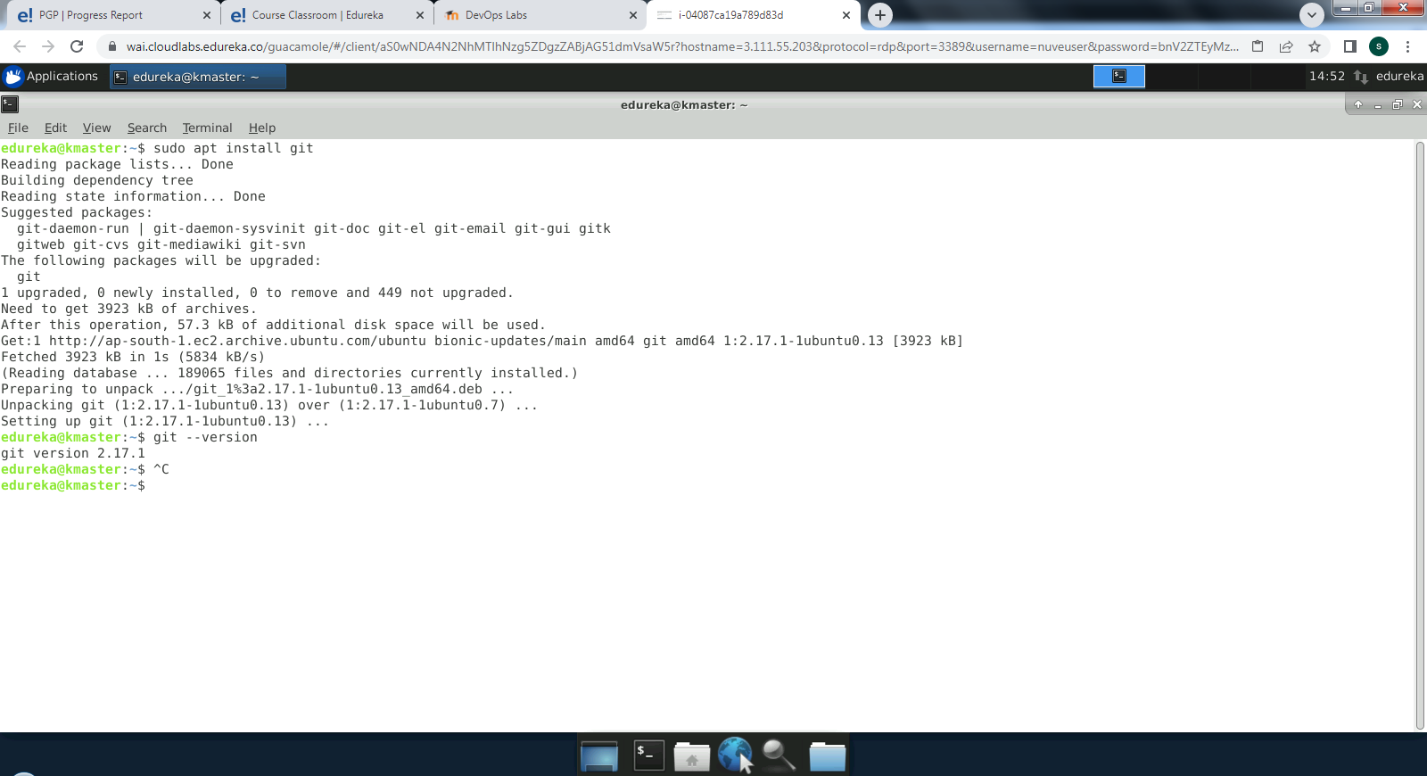

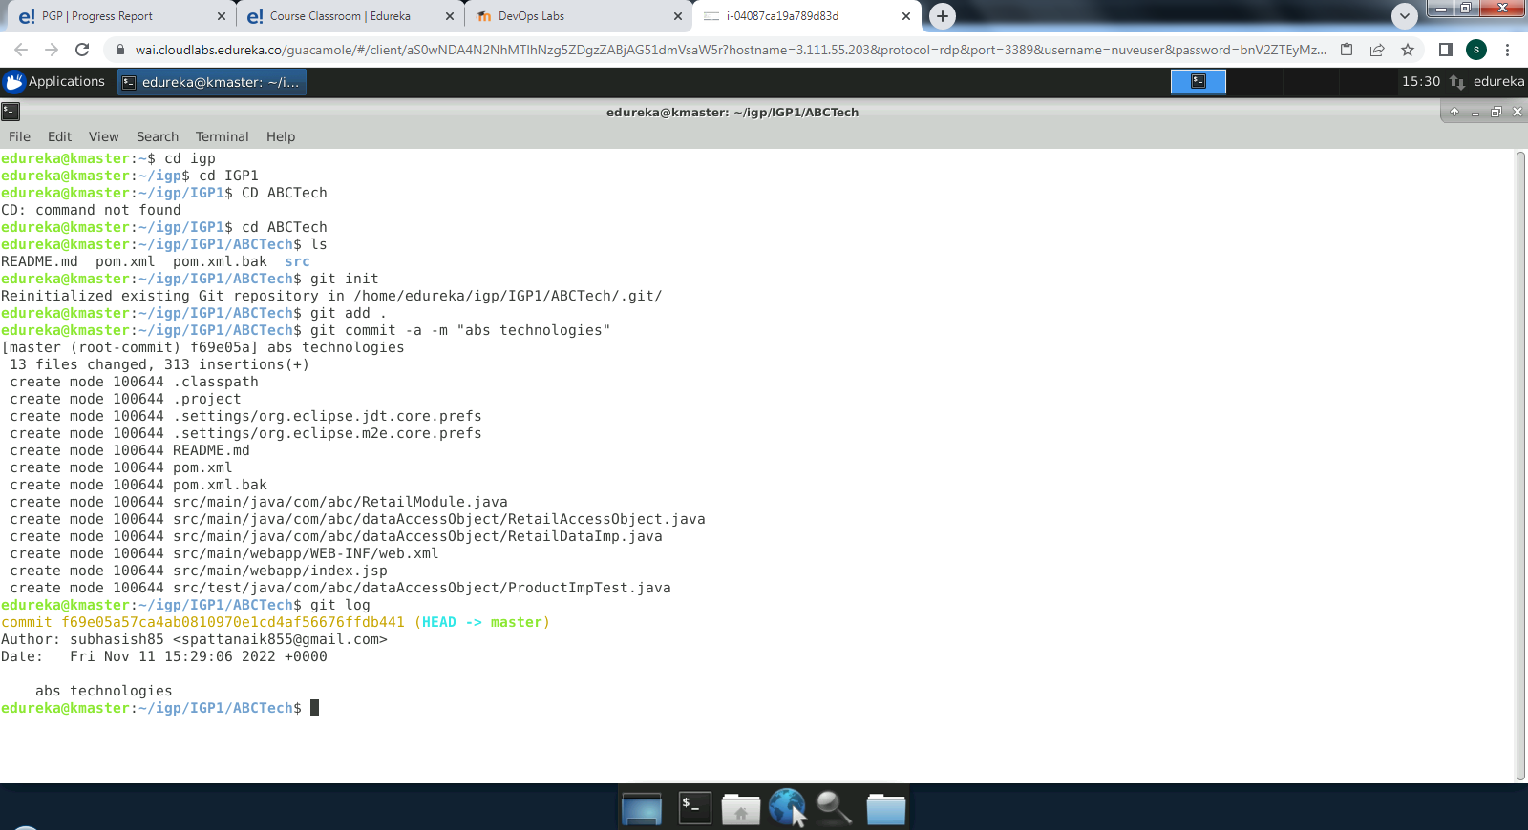

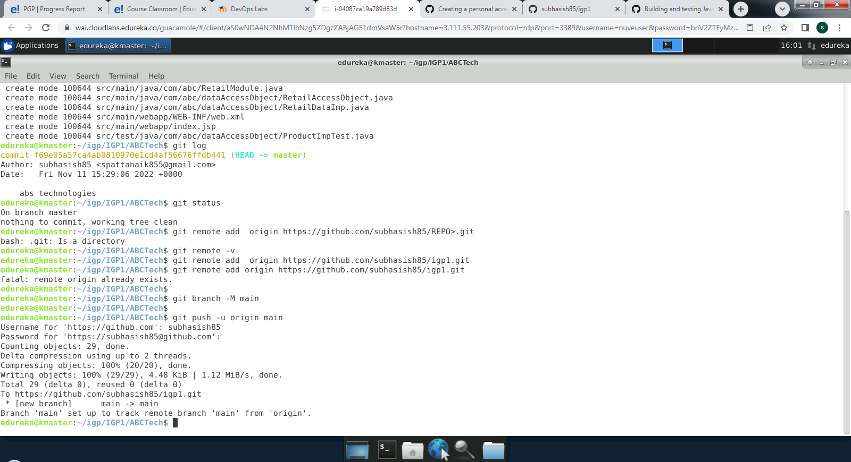

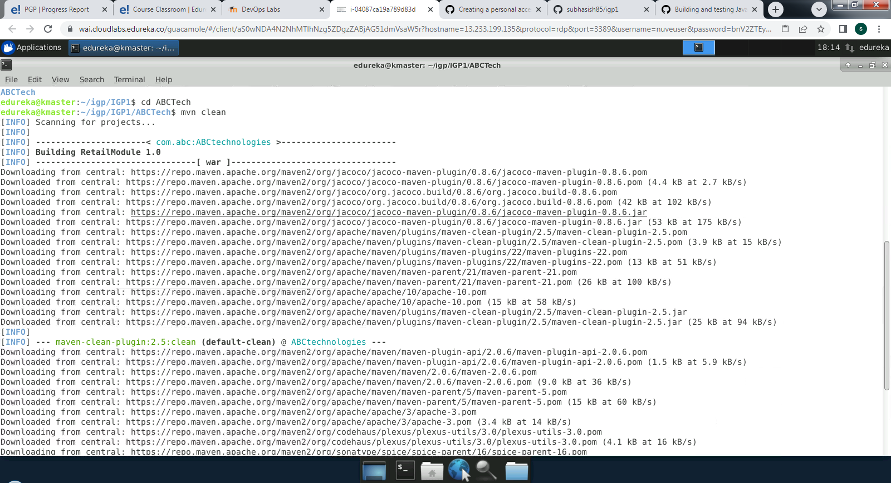

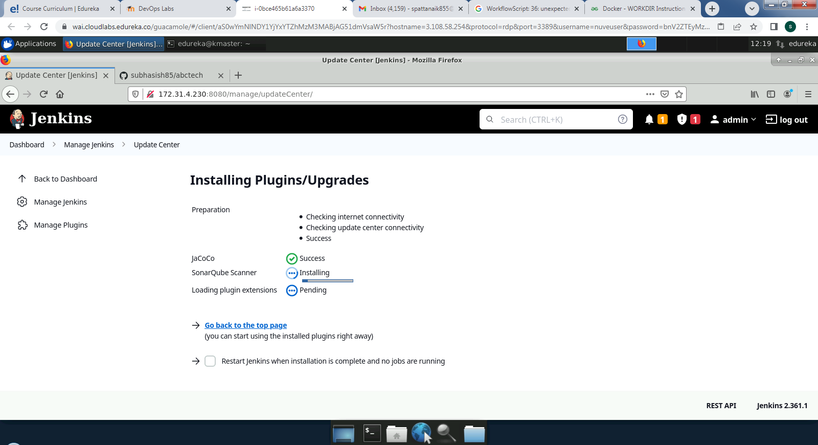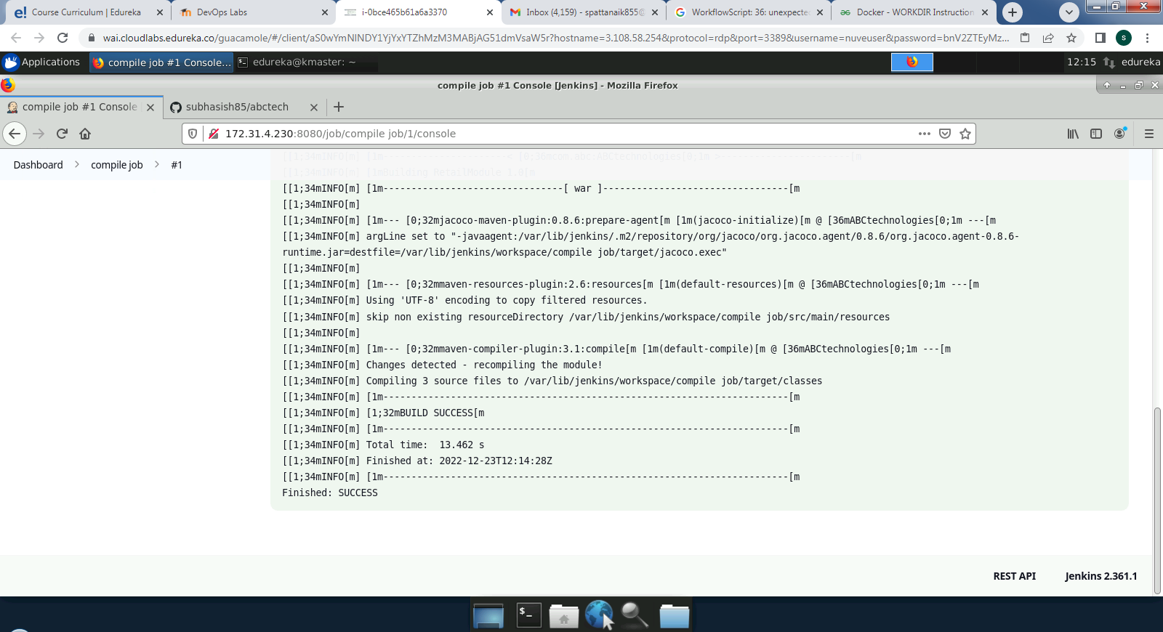

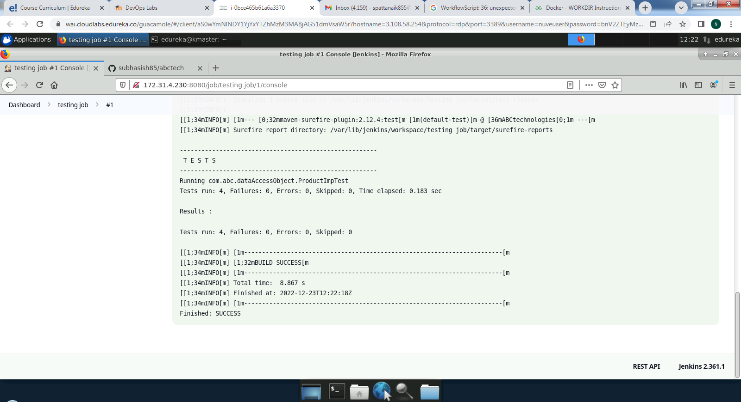

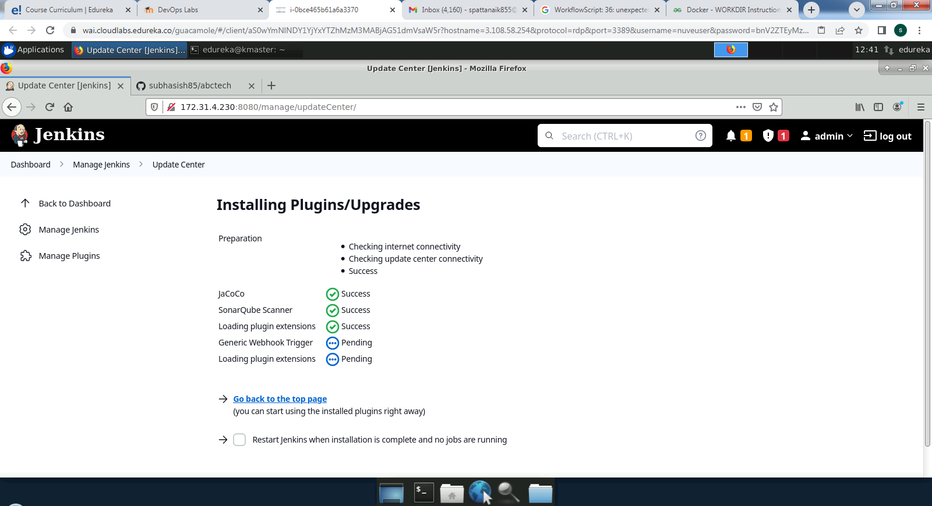

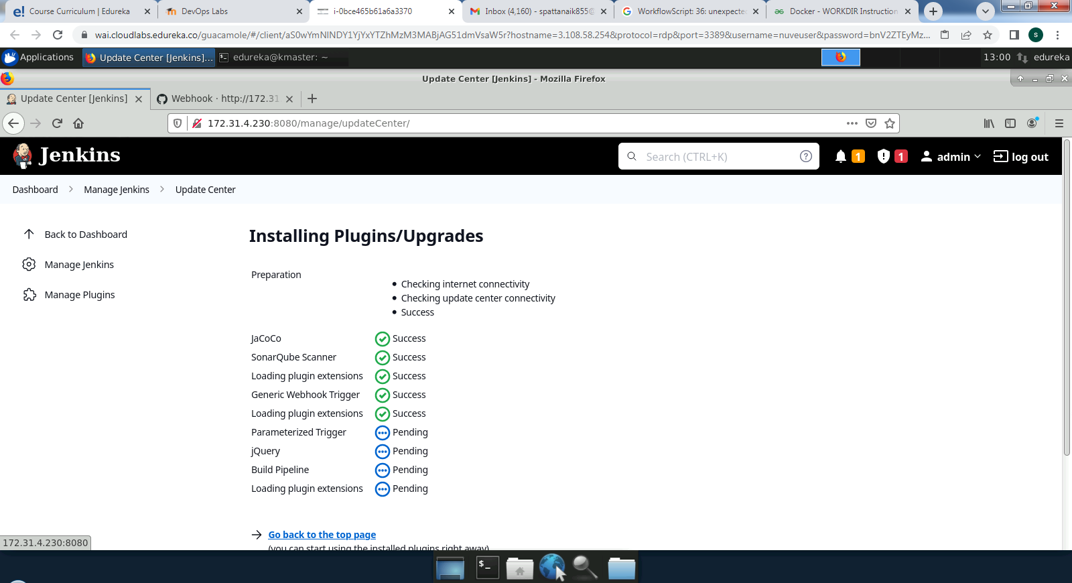

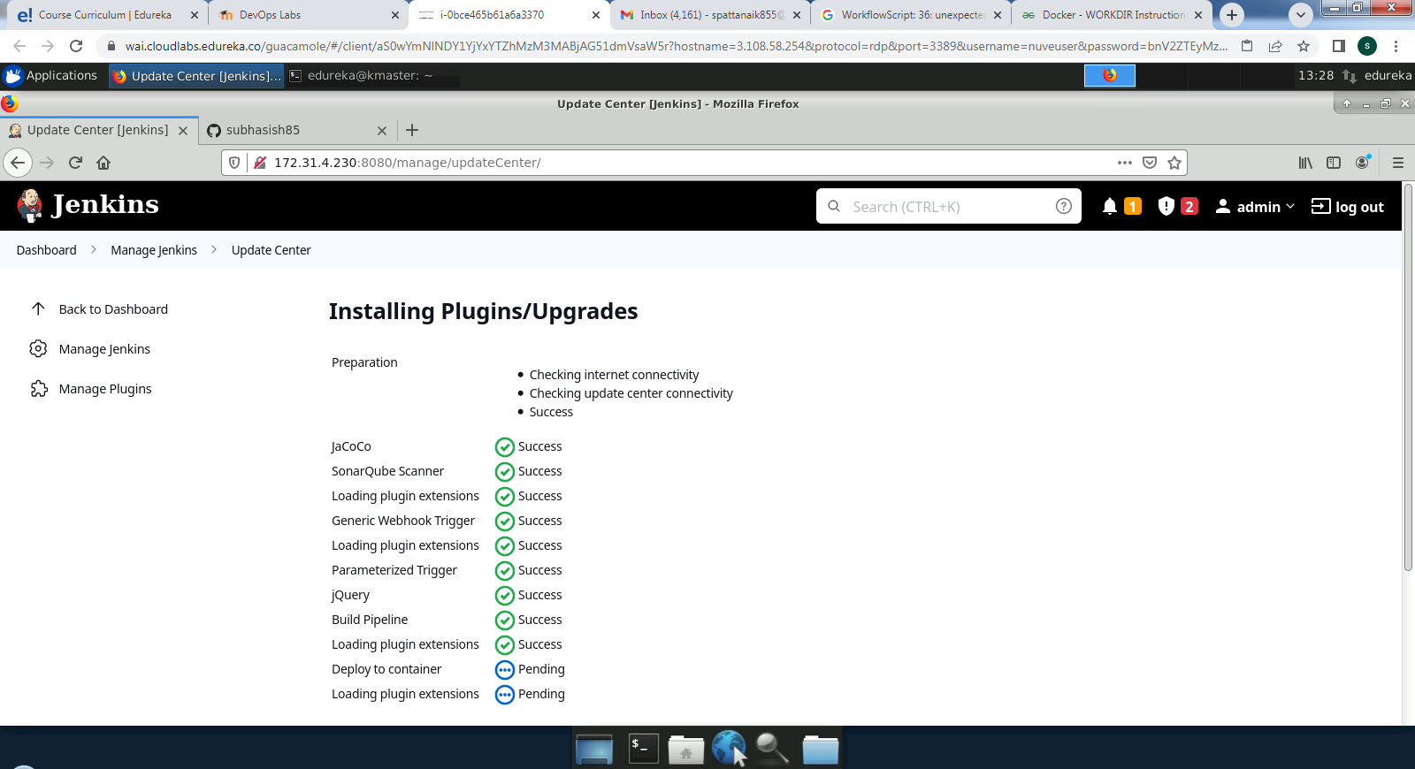

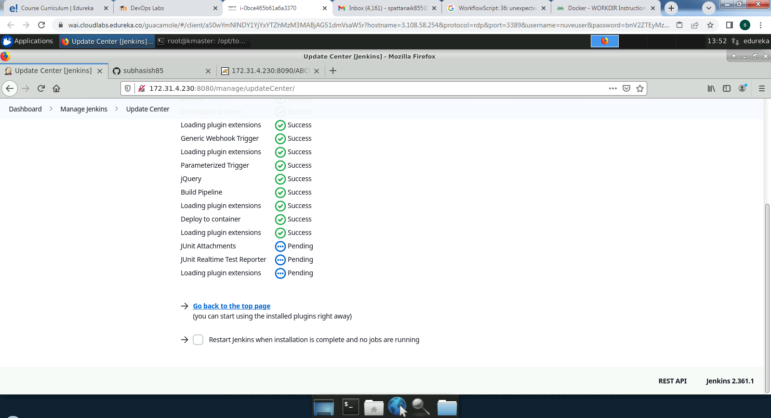

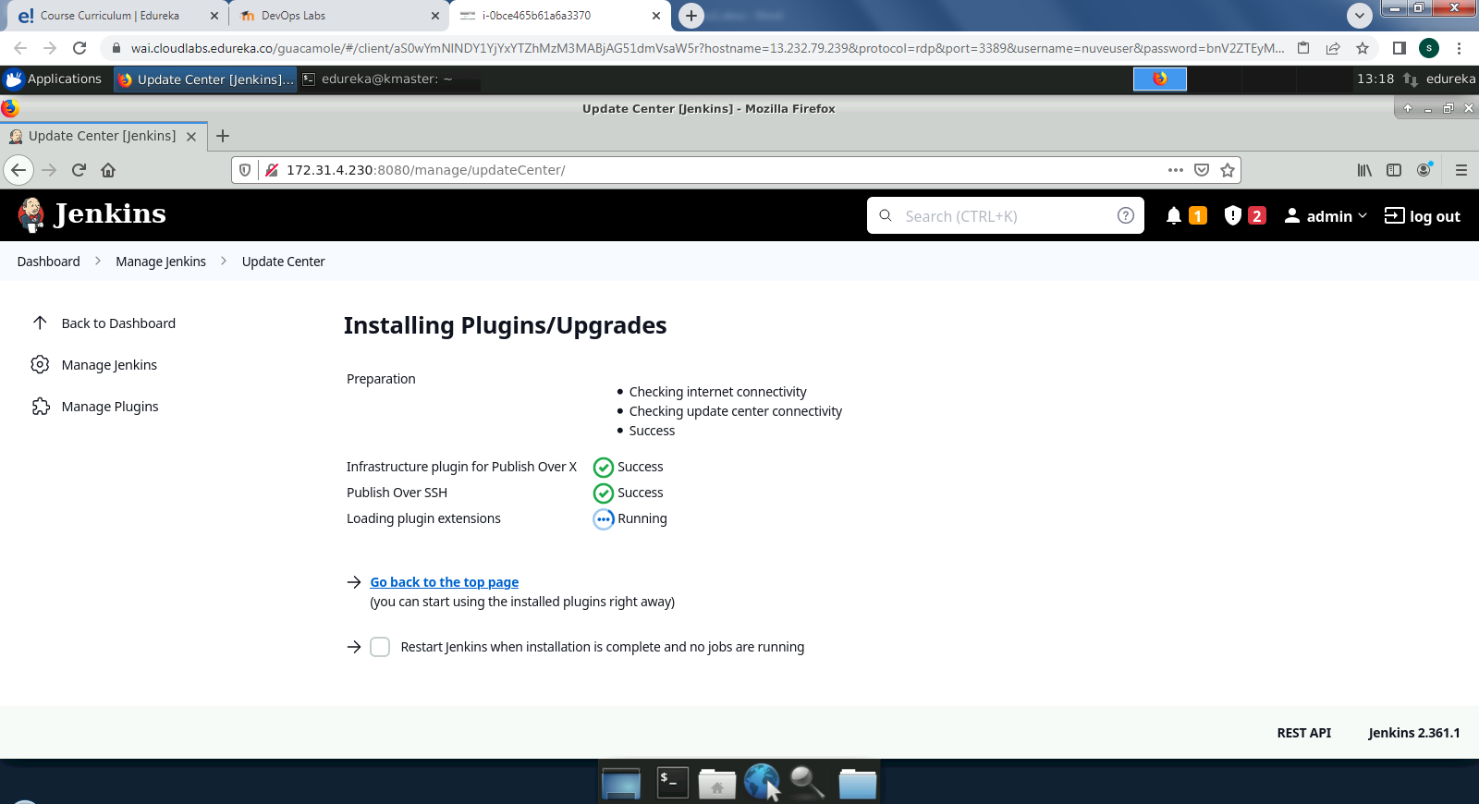

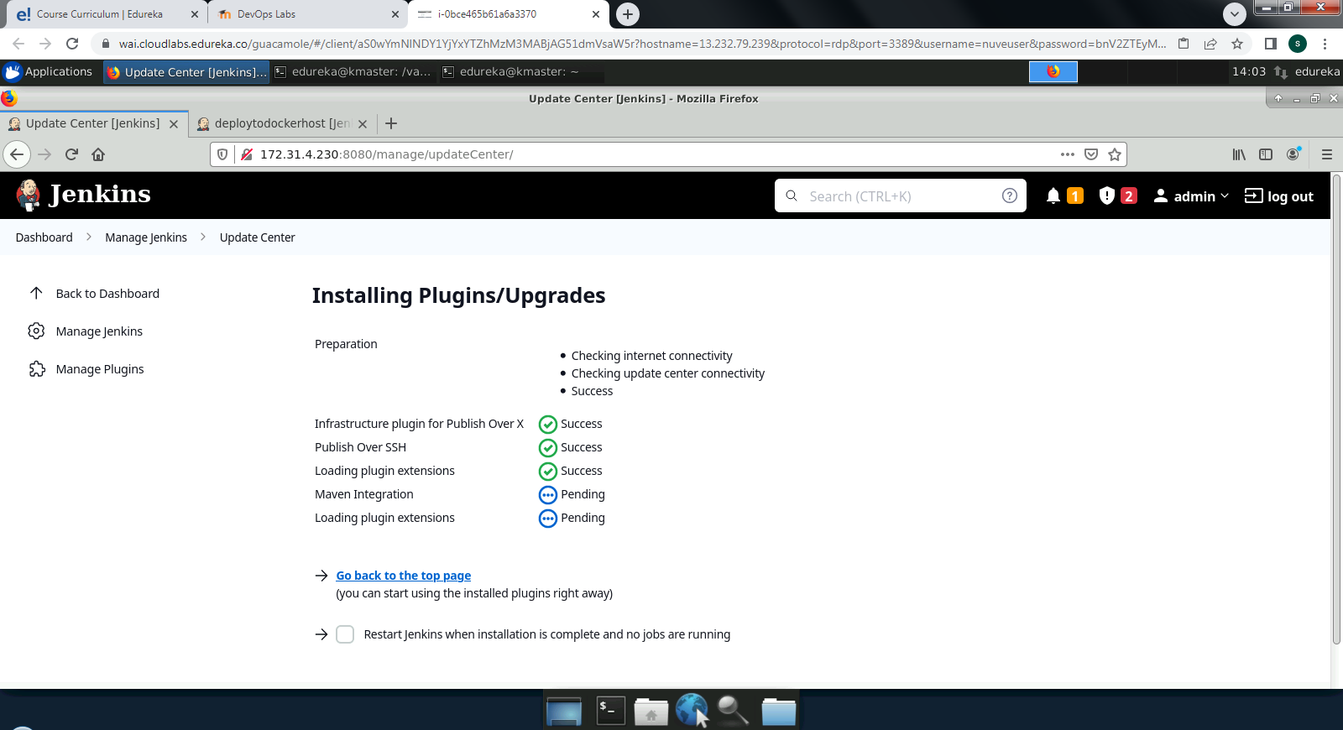

















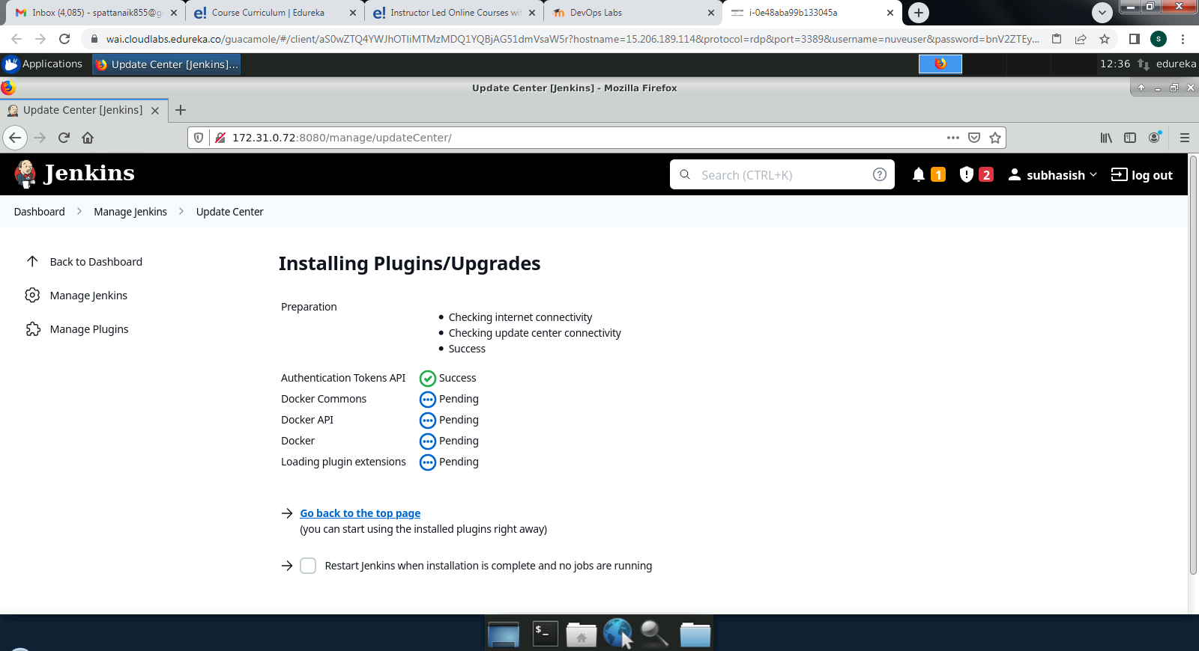

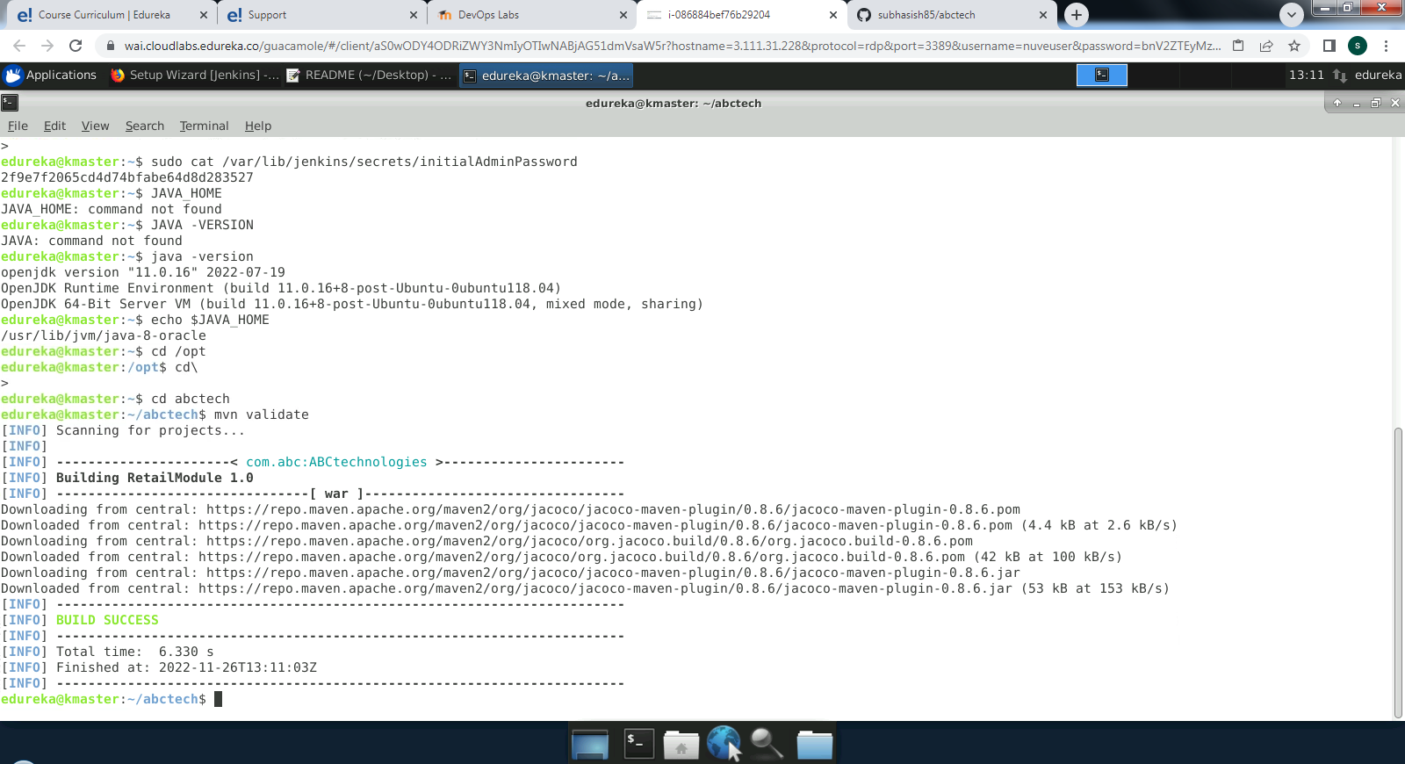

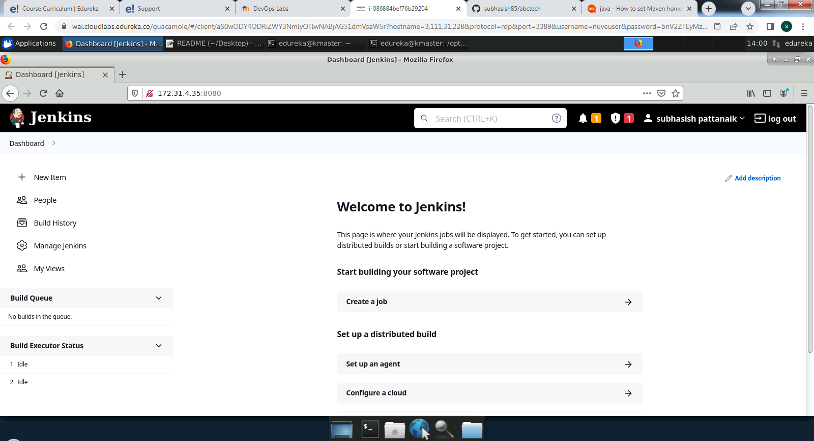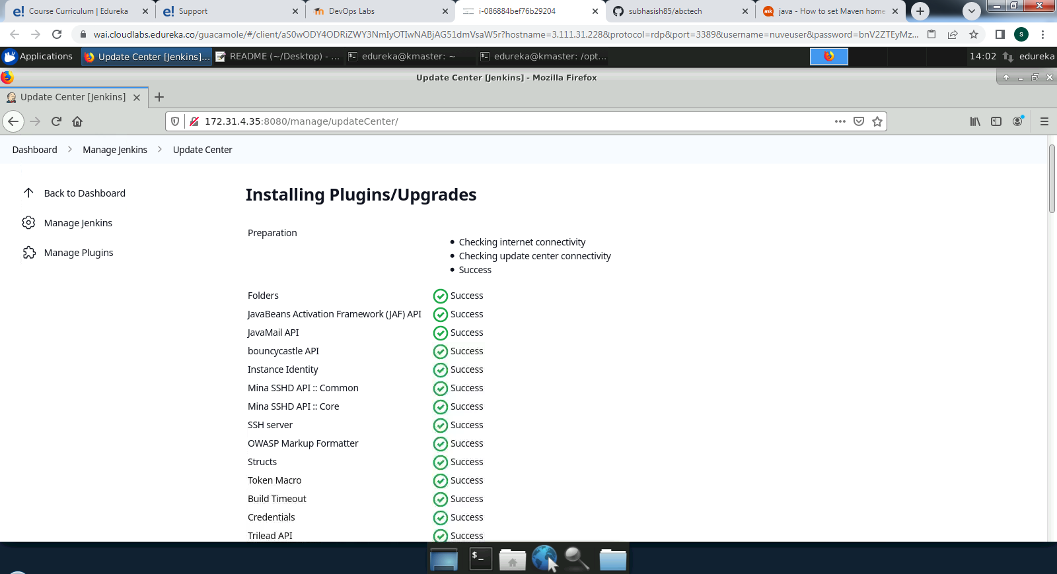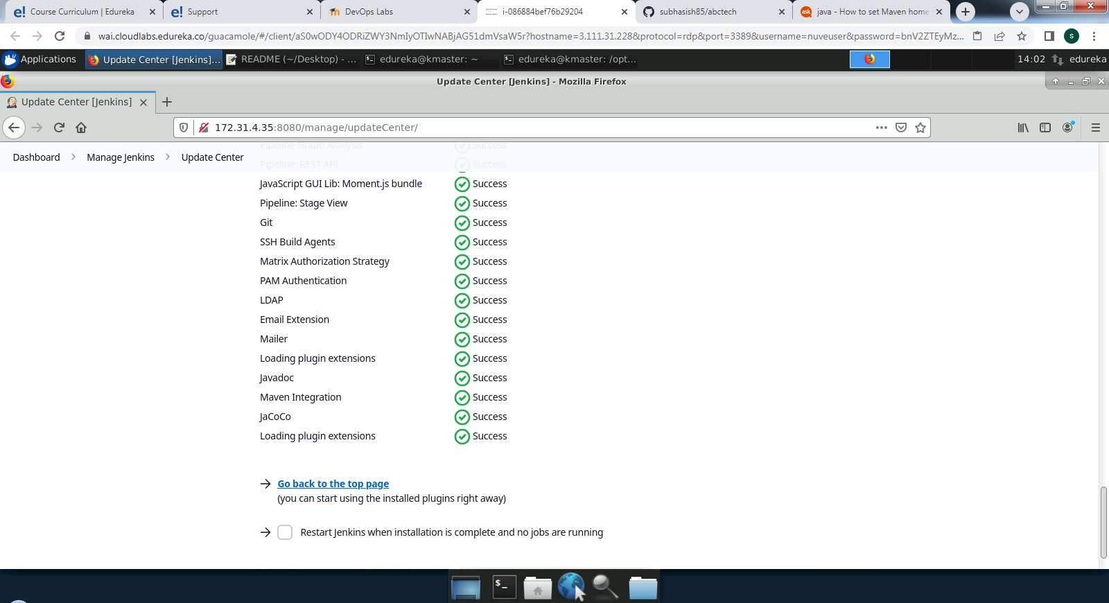

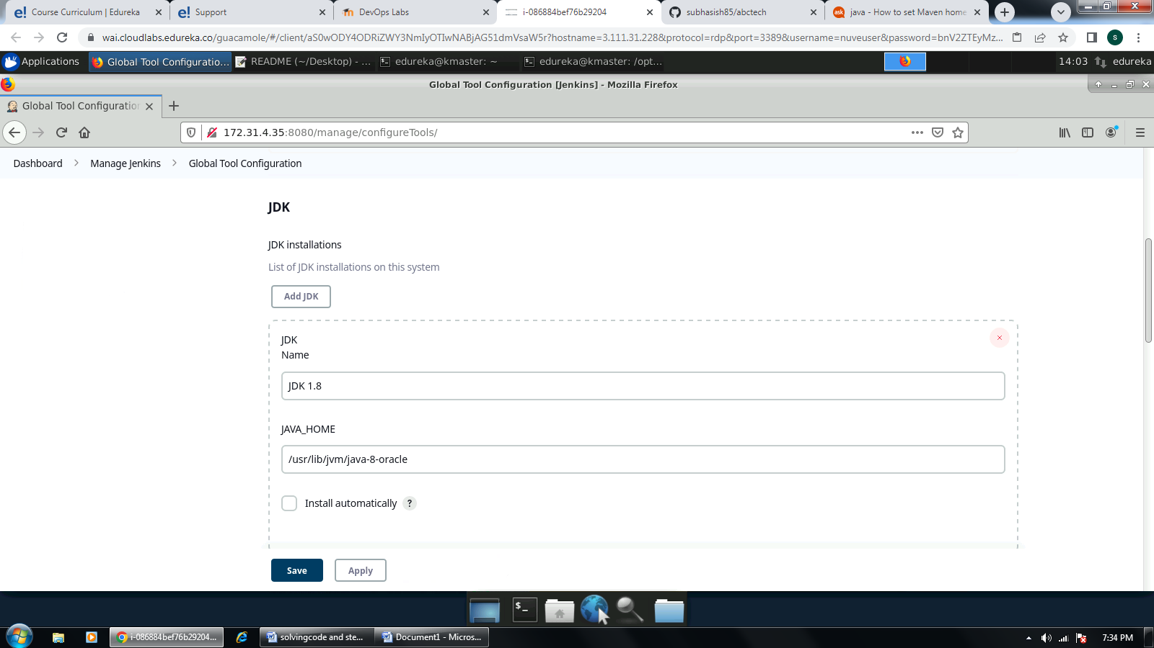

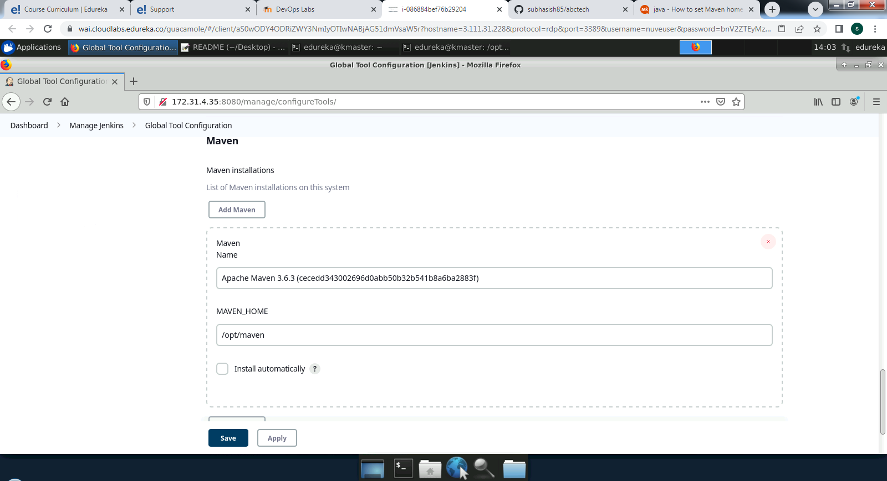

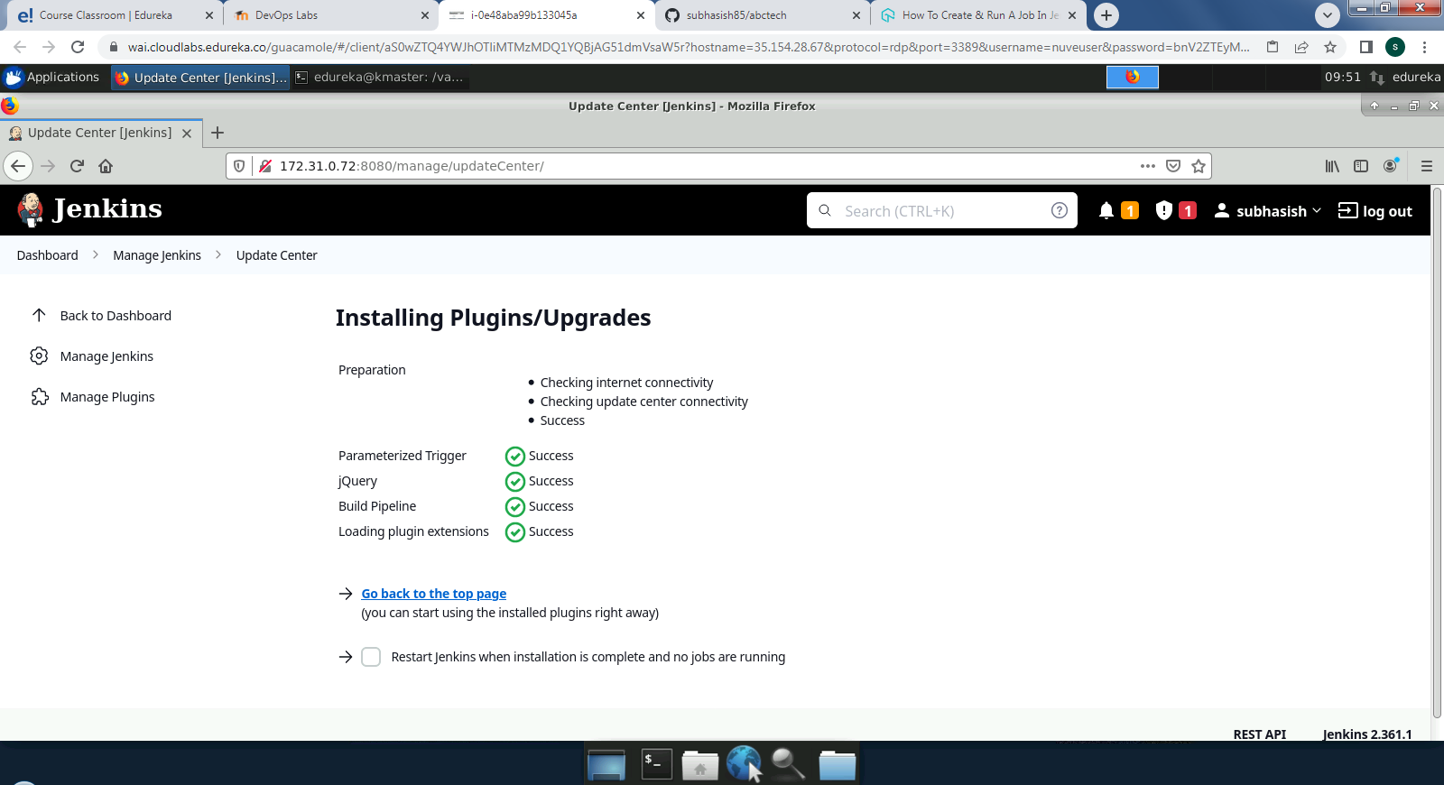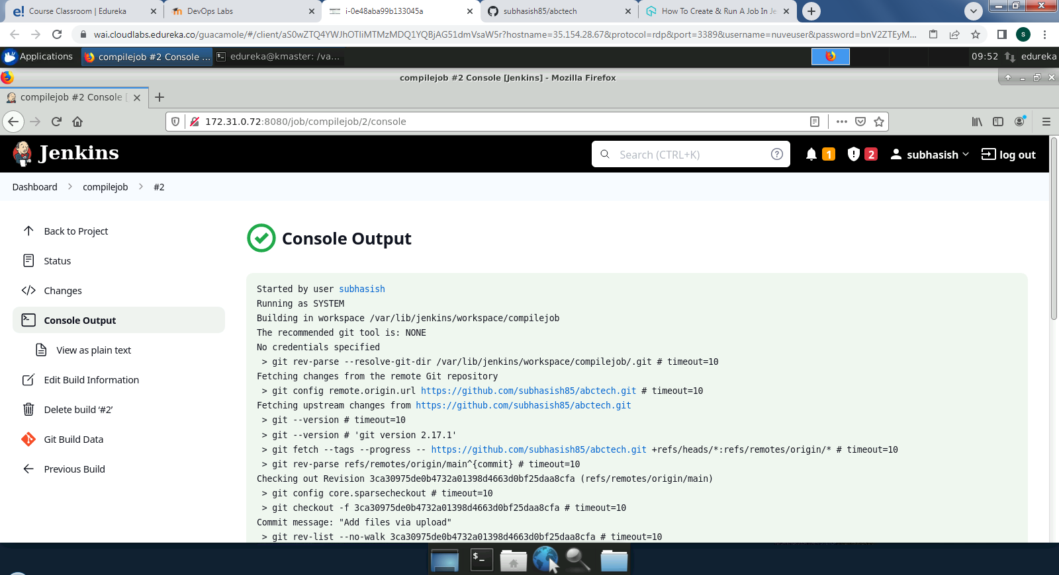

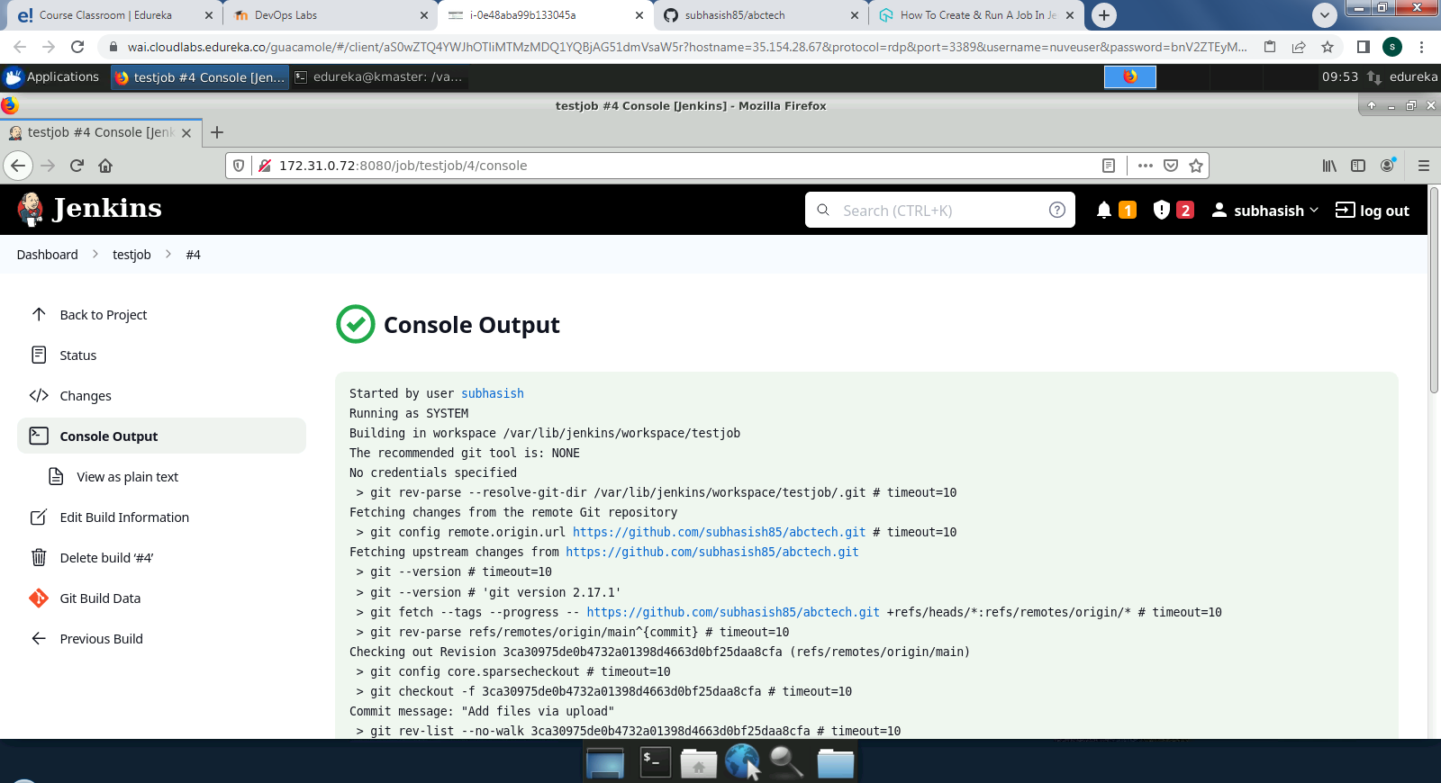

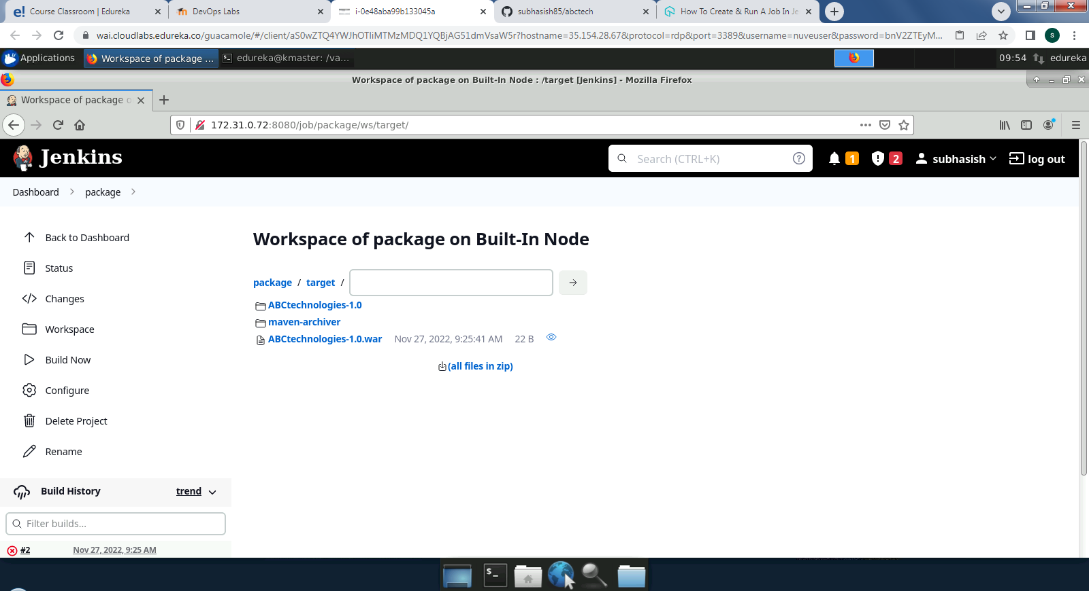CICD PIPLINE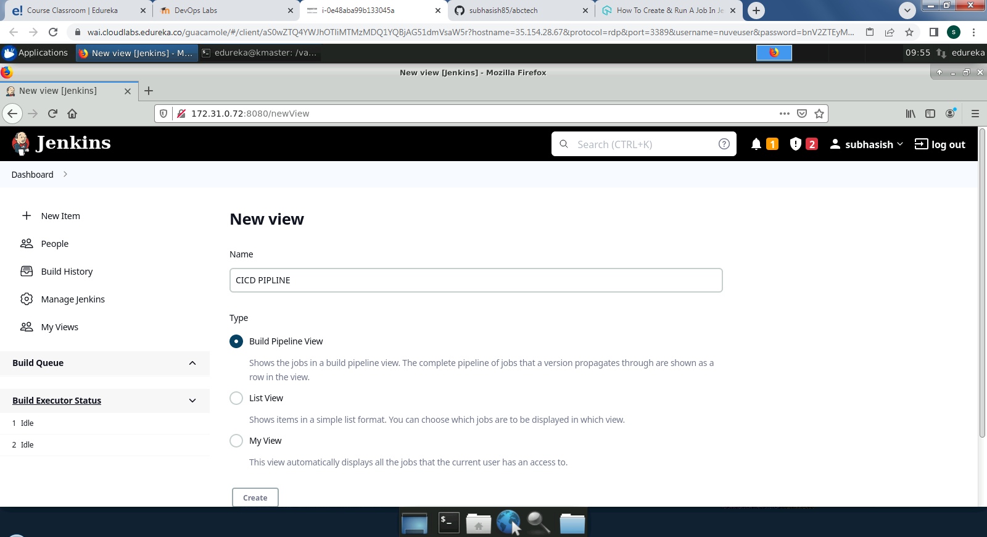

CICD PIPLINE

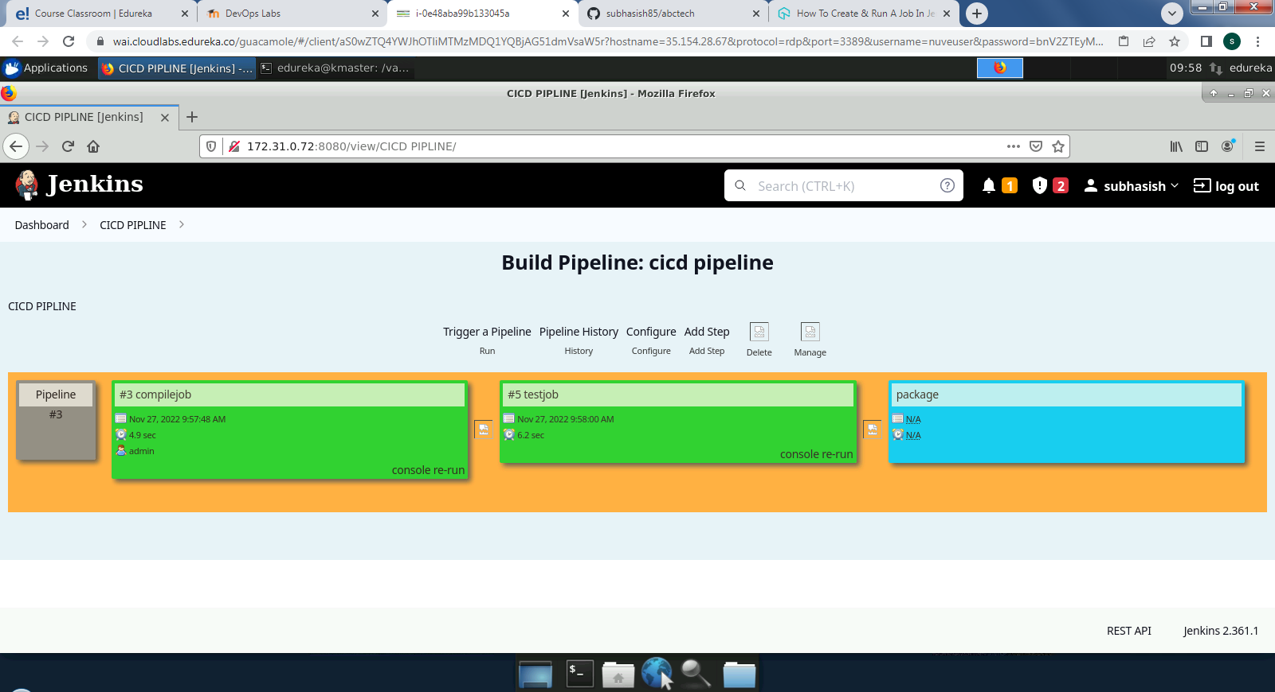

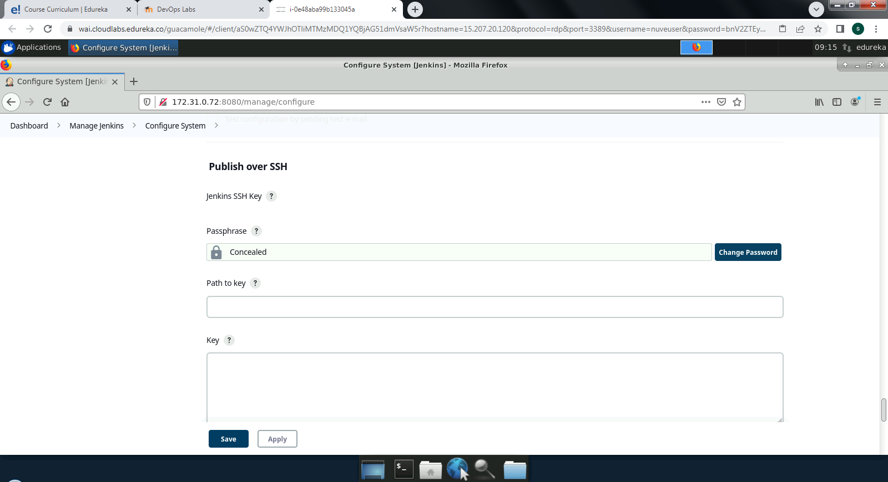

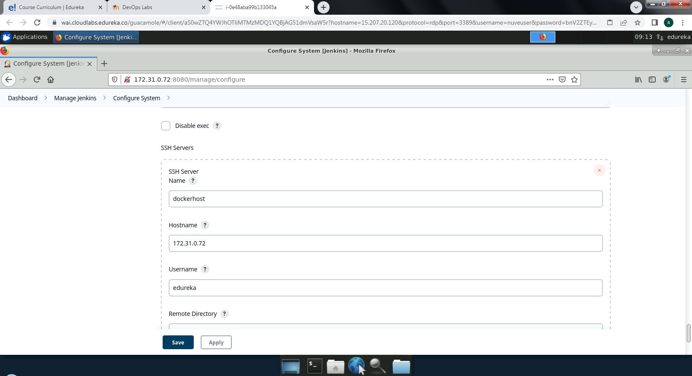

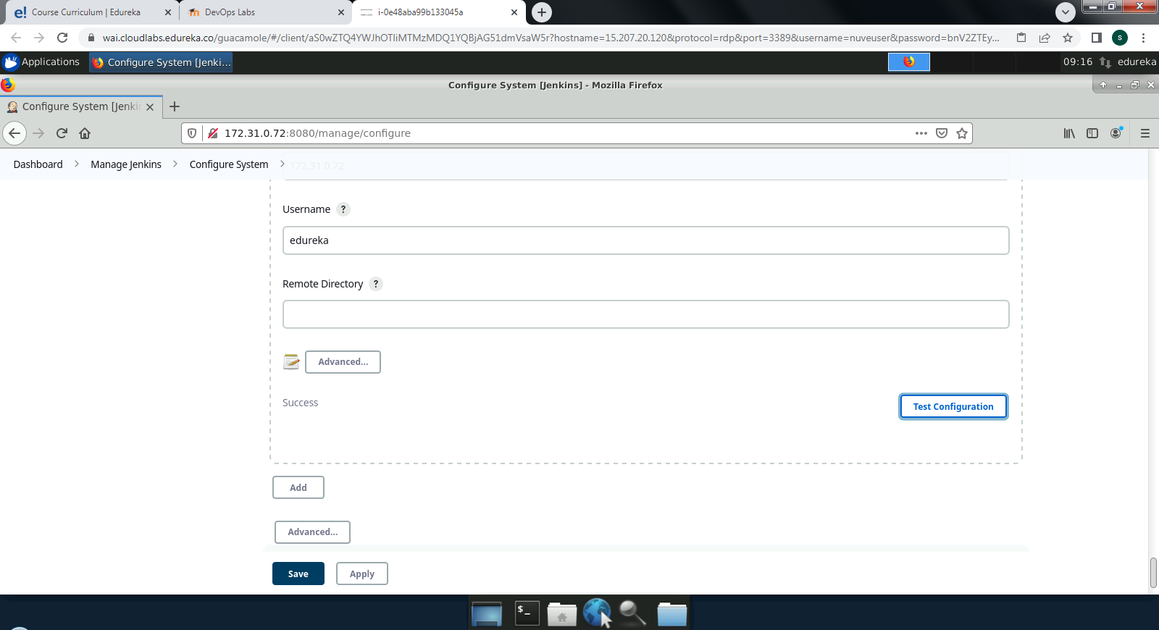

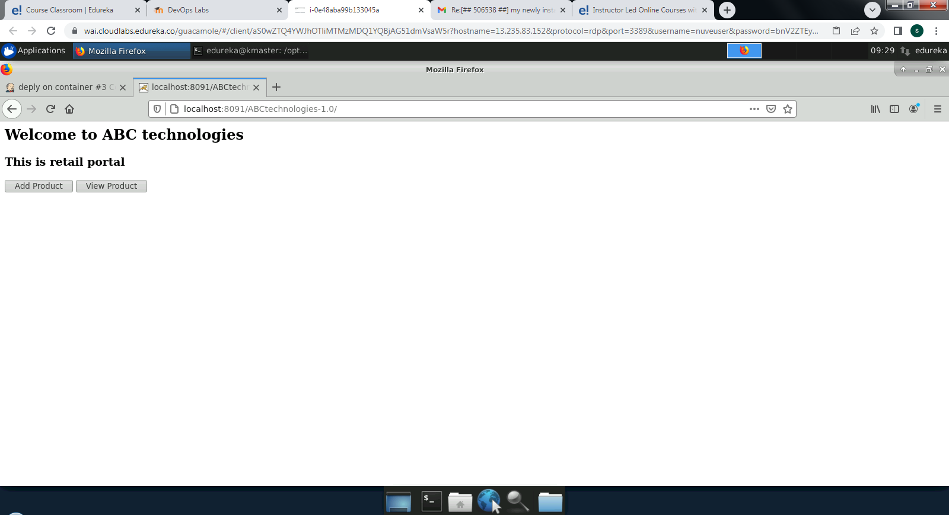

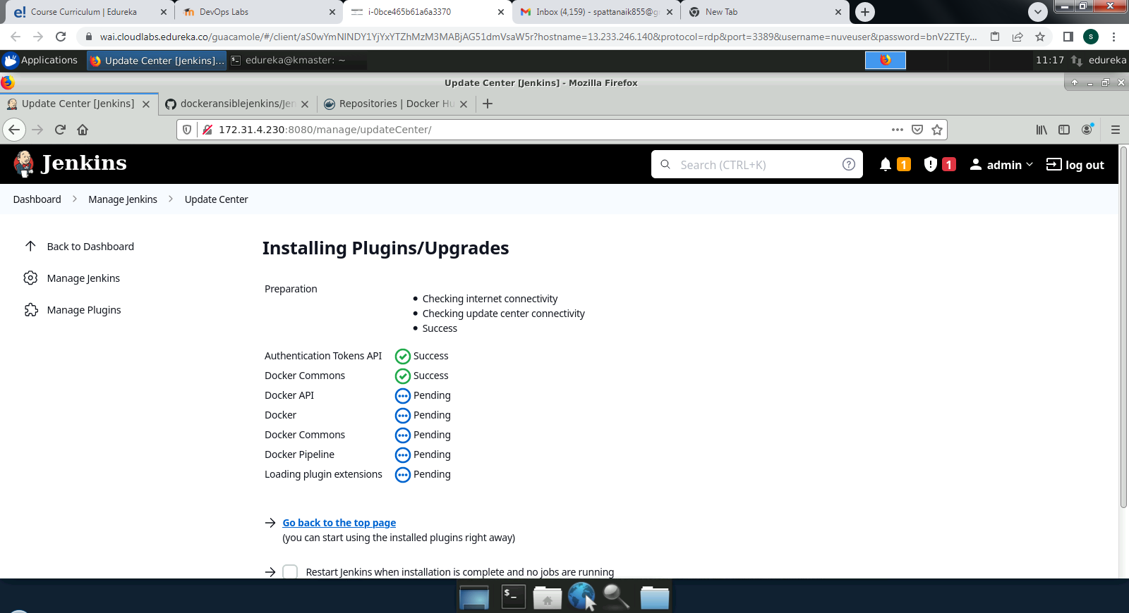

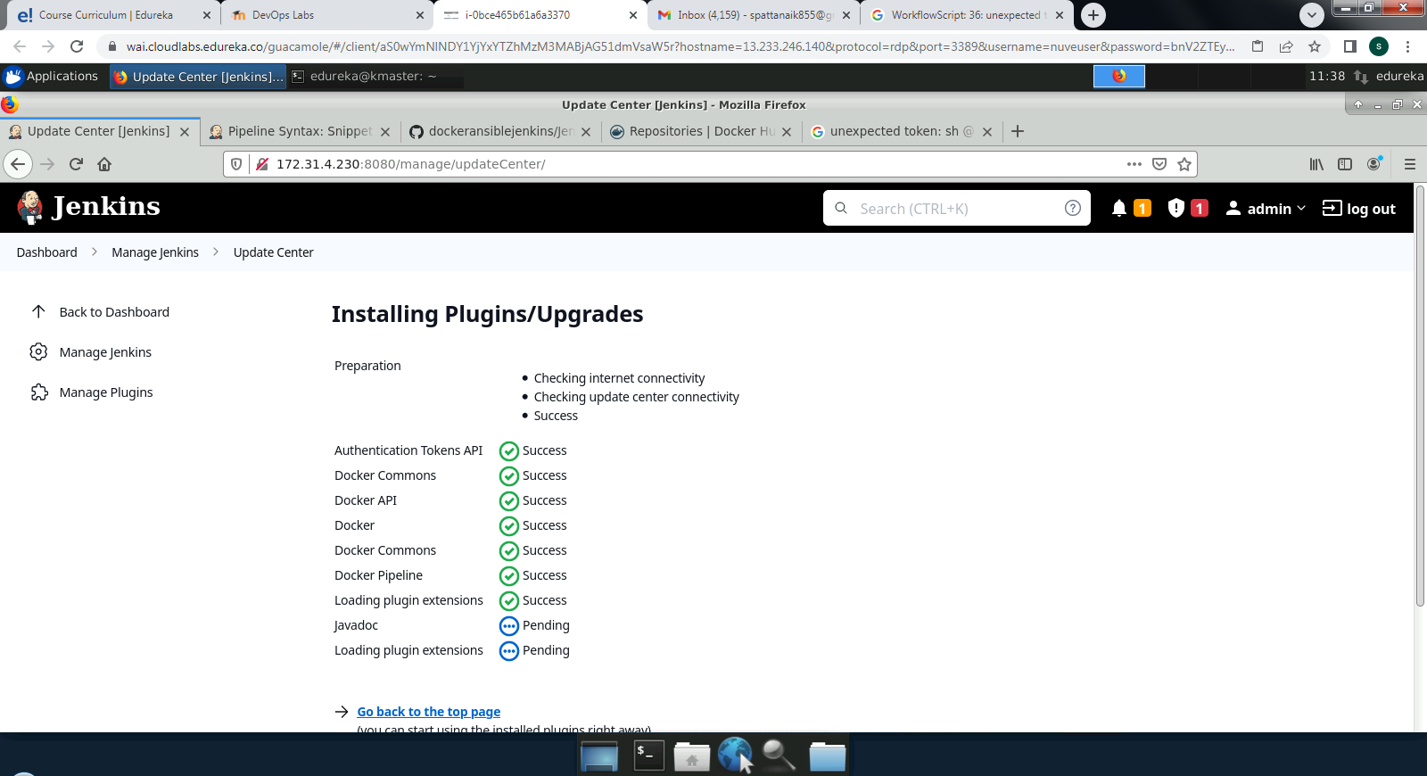















CICD PIPLINE

CICD PIPLINE















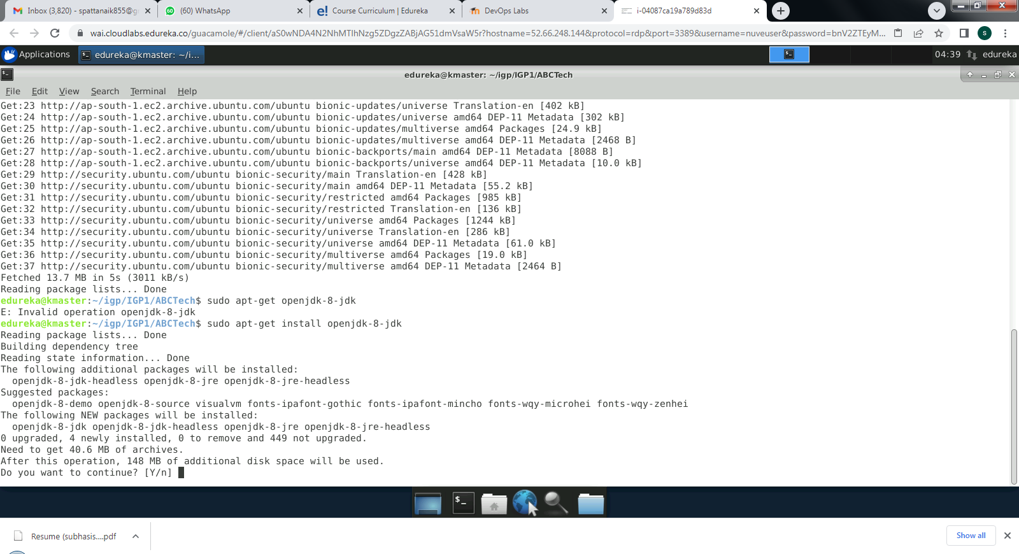

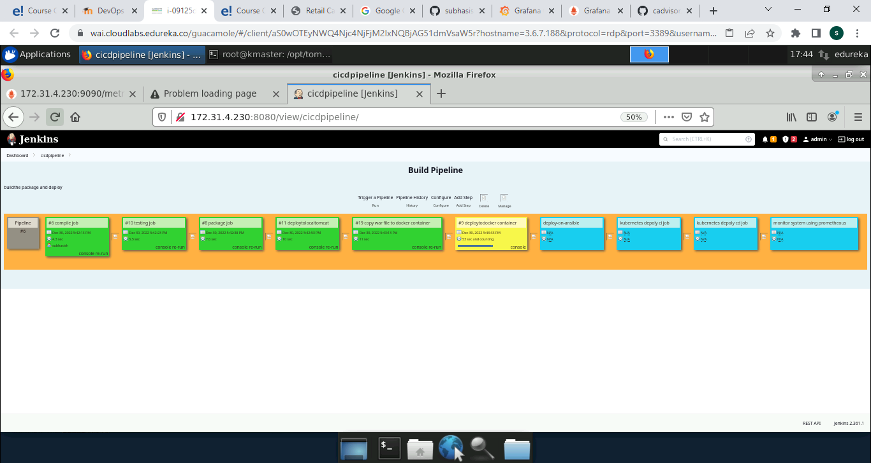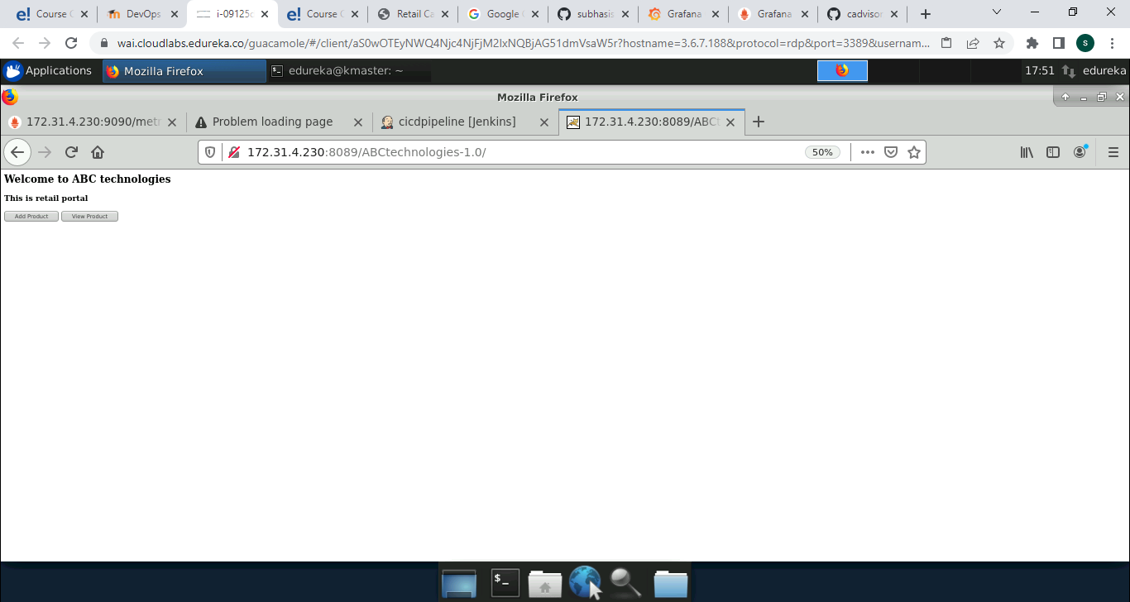

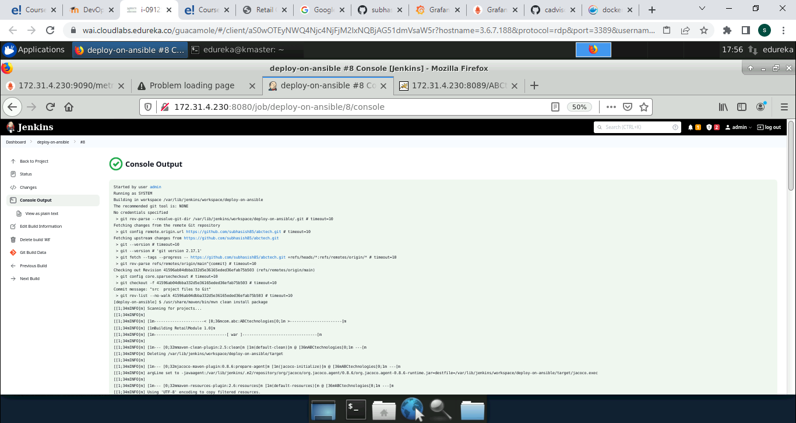

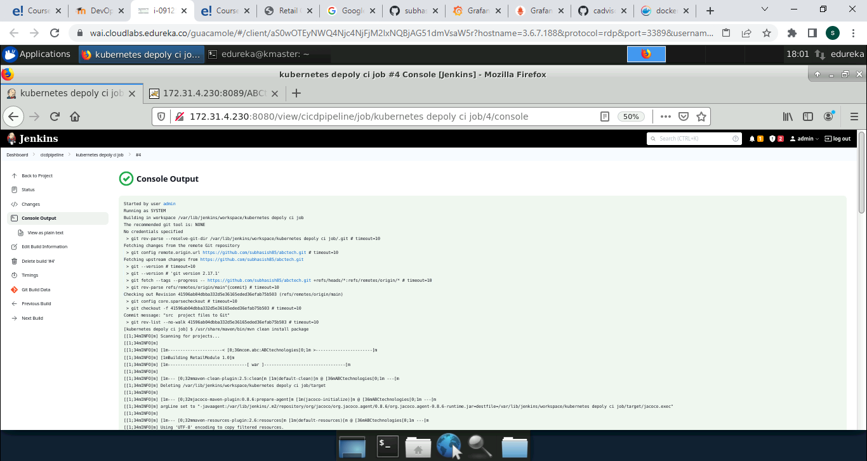

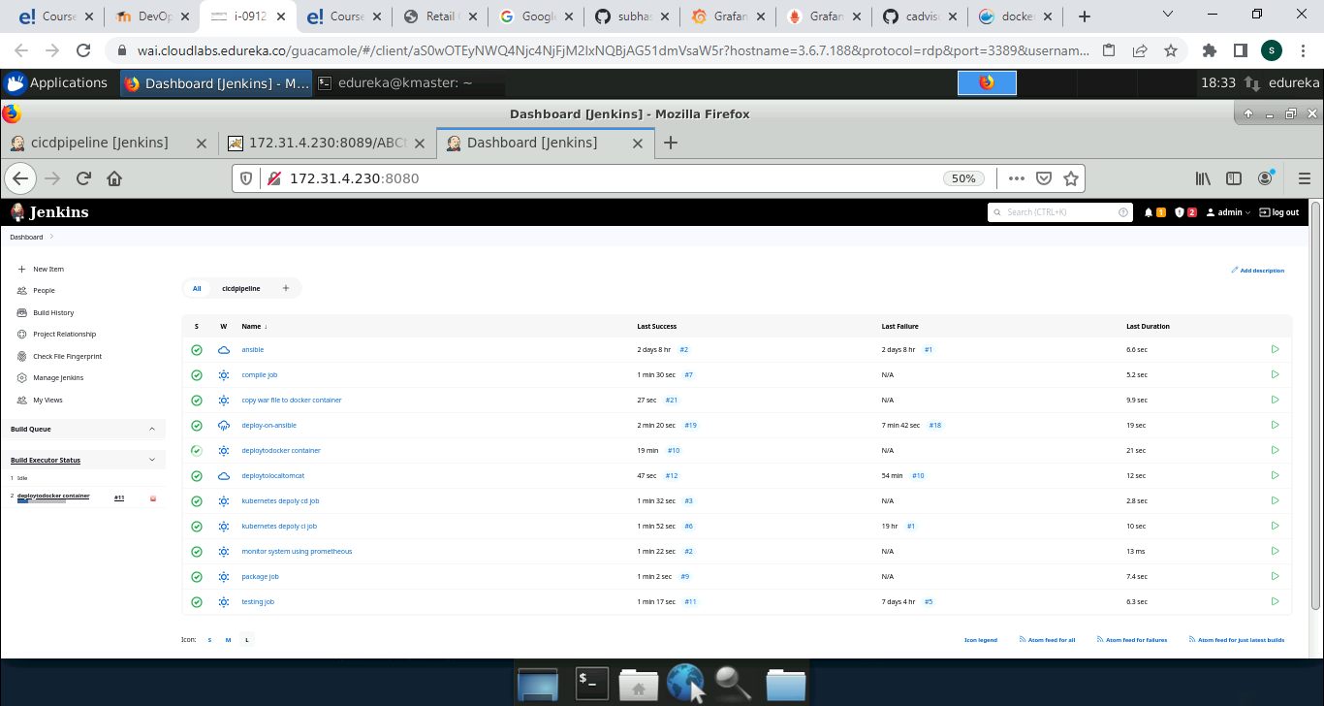

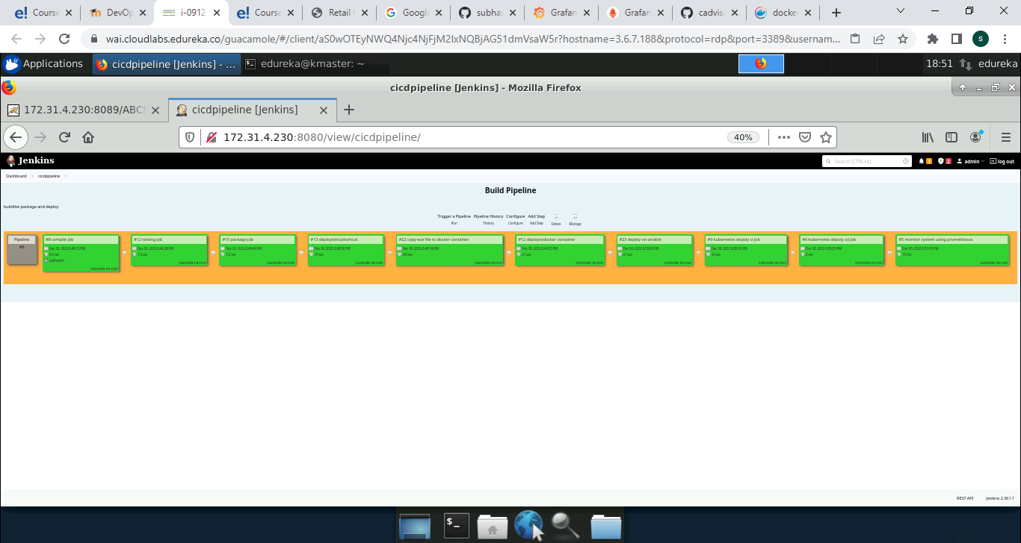

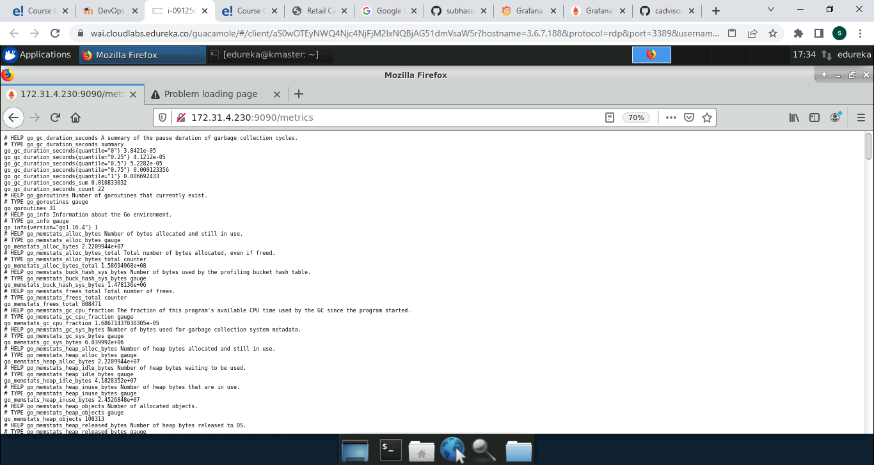

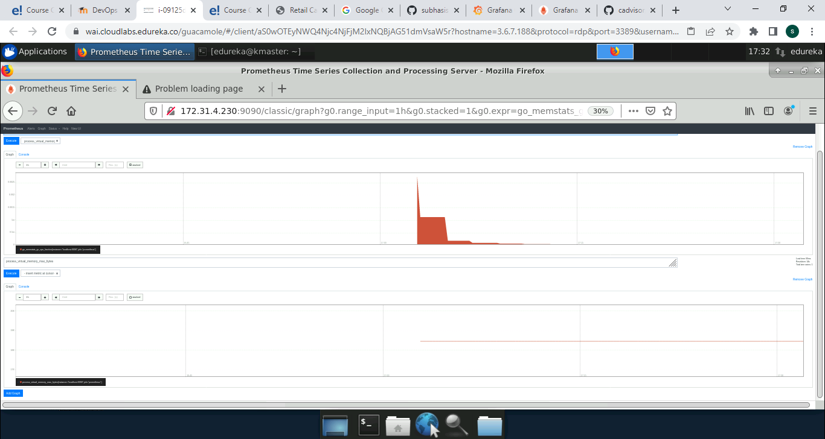**Conclusion**

DevOps is a culture-shifting strategy that has and continues to benefit a wide range of enterprises and organizations. Because of the growing demand for DevOps skills, becoming a DevOps engineer provides several advantages.

DevOps creates a seamless route for Continuous Development and Continuous Integration, bridging the gap between the conflict of goals and priorities of developers and operations team.

DevOps is a vast discipline that has become one of the most in-demand technological skills in recent years. This blog should hopefully serve as a starting point for your journey into the realm of DevOps.